**CHAPTER 1**

**INTRODUCTION**

**CHAPTER 1**

**INTRODUCTION**

Remote sensing and GIS are becoming vital tools in day to day applications. As the science and technology are becoming essential part of human life, these tools are also helping the man kind for the applications like healthcare applications, emergency services and other services. It includes planning, location identification, database management, disaster management, etc. The reason behind this sudden surge, is the use of GIS in healthcare application is the spatial dependency of health related factors and limited resources for ever health requirements need to be addressed in spatial domain in order to identify what is needed at individual location rather than looking into a problem as a whole. Thus, it has become important to recognize local healthcare needs given the healthcare demands, social status and services that are available in the locality. This is where RS & GIS could function as very important tools.

**1.1. REMOTE SENSING**

Remote Sensing is the science and art of acquiring information (spectral, spatial, and temporal) about material objects, area, or phenomenon, without coming into physical contact with the objects, or area, or phenomenon under investigation. Without direct contact, some means of transferring information through space must be emphasis. In remote sensing, information transfer is accomplished by use of electromagnetic radiation (EMR). EMR is a form of energy that reveals its presence by the observable effects it produces when it strikes the matter. EMR is considered to span the spectrum of wavelengths from 10-10 mm to cosmic rays up to 1010 mm, the broadcast wavelengths, which extend from 0.30-15 mm

* + 1. **GOOGLE EARTH**

Google Earth is a [virtual globe](http://en.wikipedia.org/wiki/Virtual_globe), [map](http://en.wikipedia.org/wiki/Map) and [geographical](http://en.wikipedia.org/wiki/Geography) information program that was originally called EarthViewer 3D, and was created by [Keyhole, Inc](http://en.wikipedia.org/wiki/Keyhole,_Inc), a company acquired by [Google](http://en.wikipedia.org/wiki/Google) in 2004. It maps the Earth by the [superimposition](http://en.wikipedia.org/wiki/Superimposition) of images obtained from [satellite imagery](http://en.wikipedia.org/wiki/Satellite_imagery), [aerial photography](http://en.wikipedia.org/wiki/Aerial_photography) and [GIS](http://en.wikipedia.org/wiki/Geographic_information_system) [3D](http://en.wikipedia.org/wiki/Computer_graphics) globe.

Google Earth displays satellite images of varying resolution of the Earth's surface, allowing users to see things like cities and houses looking perpendicularly down or at an [oblique](http://en.wikipedia.org/wiki/Angle#Types_of_angles) angle (see also [bird's eye view](http://en.wikipedia.org/wiki/Bird%27s_eye_view)). The degree of resolution available is based somewhat on the points of interest and popularity, but most land (except for some islands) is covered in at least 15 meters of resolution.

For other parts of the surface of the Earth 3D images of terrain and buildings are available. Google Earth uses [digital elevation model](http://en.wikipedia.org/wiki/Digital_elevation_model) (DEM) data collected by [NASA](http://en.wikipedia.org/wiki/NASA)'s [Shuttle Radar Topography Mission](http://en.wikipedia.org/wiki/Shuttle_Radar_Topography_Mission) (SRTM). This means one can view the whole earth in three [dimensions](http://en.wikipedia.org/wiki/Dimension). Since November 2006, the 3D views of many mountains, including Mount Everest, have been improved by the use of supplementary DEM data to fill the gaps in SRTM coverage.

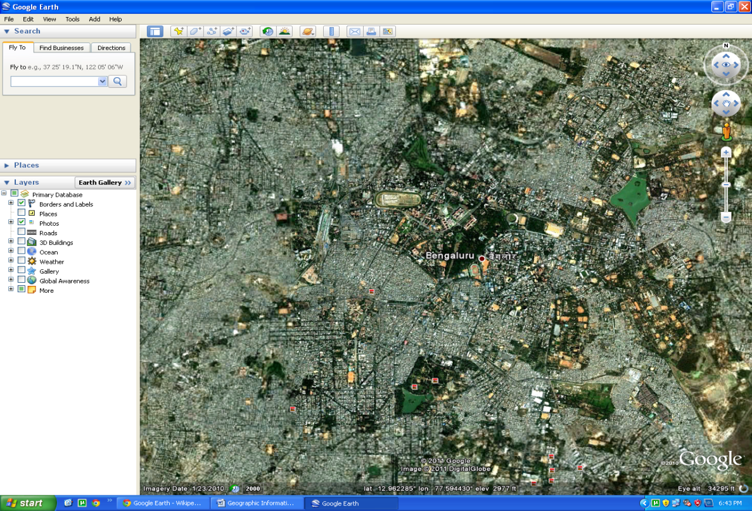

Figure1.1. Showing the Google Earth Image of Bangalore city.

**1.2. GEOGRAPHICAL INFORMATION SYSTEM**

Geographic Information System (GIS) is a computer based information system used to digitally represent and analyze the geographic features present on the Earth‘surface and the events (non-spatial attributes linked to the geography under study) that taking place on it. The meaning to represent digitally is to convert analog (smooth line) into a digital form. ―Every object present on the Earth can be geo-referenced, is the fundamental key of associating any database to GIS. Here, term database is a collection of information about things and their relationship to each other and geo-referencing refers to the location of a layer or coverage in space defined by the co-ordinate referencing system.

A GIS is an information system designed to work with data referenced by spatial / geographical coordinates. In other words, GIS is both a database system with specific capabilities for spatially referenced data as well as a set of operations for working with the data. It may also be considered as a higher order map. GIS technology integrates common database operations such as query and statistical analysis with the unique visualization and geographic analysis benefits offered by maps. These abilities distinguish GIS from other information systems and make it valuable to a wide range of public and private enterprises for explaining events, predicting outcomes, and planning strategies. A Geographic 4 Information System is a computer based system which is used to digitally reproduce and analyze the feature present on earth surface and the events that take place on it. In the light of the fact that almost 70% of the data has geographical reference as its denominator, it becomes imperative to underline the importance of a system which can represent the given data geographically.

A typical GIS can be understood by the help of various definitions given below:-

* A geographic information system (GIS) is a computer-based tool for mapping and analyzing things that exist and events that happen on Earth
* Burrough in 1986 defined GIS as, ―Set of tools for collecting, storing, retrieving at will, transforming and displaying spatial data from the real world for a particular set of purposes‖
*  Arnoff in 1989 defines GIS as, ―a computer based system that provides four sets of capabilities to handle geo-referenced data:

1. data input
2. data management (data storage and retrieval)
3. manipulation and analysis
4. Data output.

Hence GIS is looked upon as a tool to assist in decision-making and management of attributes that needs to be analyzed spatially.

**1.3. DATABASE DESIGN**

Database design is the process of producing a detailed data model of a database. This logical data model contains all the needed logical and physical design choices and physical storage parameters needed to generate a design in a Data Definition Language, which can then be used to create a database. A fully attributed data model contains detailed attributes for each entity.

The term database design can be used to describe many different parts of the design of an overall database system. Principally, and most correctly, it can be thought of as the logical design of the base data structures used to store the data. In the relational model these are the tables and views. In an object database the entities and relationships map directly to object classes and named relationships. However, the term database design could also be used to apply to the overall process of designing, not just the base data structures, but also the forms and queries used as part of the overall database application within the database management system (DBMS).

The process of doing database design generally consists of a number of steps which will be carried out by the database designer. Usually, the designer must:

* Determine the relationships between the different data elements.
* Superimpose a logical structure upon the data on the basis of these relationships.

The Design Process: The design process consists of the following steps:

a) **Determine the purpose of your database** – This helps prepare you for the remaining steps.

b) **Find and organize the information required** – Gather all of the types of information you might want to record in the database, such as product name and order number.

c) **Divide the information into tables** – Divide your information items into major entities or subjects, such as Services, Products or Orders. Each subject then becomes a table.

d) **Turn information items into columns** – Decide what information you want to store in each table. Each item becomes a field, and is displayed as a column in the table. For example, hospital table might include fields such as hospital id, name, address, contact no etc.,

e) **Specify primary keys** – Choose each table‘s primary key. The primary key is a column that is used to uniquely identify each row. An example might be hospital ID or department ID.

f) **Set up the table relationships** – Look at each table and decide how the data in one table is related to the data in other tables. Add fields to tables or create new tables to clarify the relationships, as necessary.

g) **Refine your design** – Analyze your design for errors. Create the tables and add a few records of sample data. See if you can get the results you want from your tables. Make adjustments to the design, as needed.

h) **Apply the normalization rules** – Apply the data normalization rules to see if your tables are structured correctly. Make adjustments to the tables.

**1.4. RELATIONAL DATABASE**

A relational database matches data by using common characteristics found within the data set. The resulting groups of data are organized and are much easier for many people to understand. For example, a data set containing all the hospitals in a specific department like Anesthesiology can be grouped by department concerned; or it can be grouped by the doctors who are Anaestists; or it can be grouped by the facility available; and so on. Such a grouping uses the relational model (a technical term for this is schema). Hence, such a database is called a ―relational database. The software used to do this grouping is called a relational database management system (RDBMS). The term relational database‖ often refers to this type of software. Relational databases are currently the predominant choice in storing financial records, medical records, manufacturing and logistical information, personnel data and much more.

**1.4.1. Contents:** A relational database is a collection of relations (frequently called tables). Other items are frequently considered part of the database, as they help to organize and structure the data, in addition to forcing the database to conform to a set of requirements.

**1.4.2. Relations or Tables:** A relation is defined as a set of tuples that have the same attributes. A tuple usually represents an object and information about that object. Objects are typically physical objects or concepts. A relation is usually described as a table, which is organized into rows and columns. All the data referenced by an

Attribute are in the same domain and conform to the same constraints. The relational model specifies that the tuples of a relation have no specific order and that the tuples, in turn, impose no order on the attributes. Applications access data by specifying queries, which use operations such as select to identify tuples, project to identify attributes, and join to combine relations. Relations can be modified using the insert, delete, and update operators. New tuples can supply explicit values or be derived from a query. Similarly, queries identify tuples for updating or deleting. It is necessary for each tuple of a relation to be uniquely identifiable by some combination (one or more) of its attribute values. This combination is referred to as the primary key.

**1.4.3. Primary keys:** A primary key uniquely defines a relationship within a database. In order for an attribute to be a good primary key it must not repeat. While natural attributes are sometimes good primary keys, Surrogate keys are often used instead. A surrogate key is an artificial attribute assigned to an object which uniquely identifies it (for instance, in a table of information about students at a school they might all be assigned a Student ID in order to differentiate them). The surrogate key has no intrinsic (inherent) meaning, but rather is useful through its ability to uniquely identify a tuple. Another common occurrence, especially in regards to N:M cardinality is the composite key. A composite key is a key made up of two or more attributes within a table that (together) uniquely identify a record. (For example, in a database relating students, teachers, and classes. Classes could be uniquely identified by a composite key of their room number and time slot, since no other class could have exactly the same combination of attributes. In fact, use of a composite key such as this can be a form of data verification, albeit a weak one.)

**1.4.4. Foreign keys:** A foreign key is a reference to a key in another relation, meaning that the referencing table has, as one of its attributes, the values of a key in the referenced table. Foreign keys need not have unique values in the referencing relation. Foreign keys effectively use the values of attributes in the referenced relation to restrict the domain of one or more attributes in the referencing relation. A foreign key could be described formally as: ―For all tables in the referencing relation projected over the referencing attributes.

**1.5. SQL: STRUCTURED QUERY LANGUAGE**

SQL often referred to as Structured Query Language, is a database computer language designed for managing data in relational database management systems (RDBMS), and originally based upon relational algebra and calculus. Its scope includes data insert, query, update and delete, schema creation and modification, and data access control.

Language elements: The SQL language is sub-divided into several language elements, including:

*  Clauses, which are constituent components of statements and queries. (In some cases, these are optional.)
* Expressions, which can produce either scalar values or tables consisting of columns and rows of data.
* Predicates, which specify conditions that can be evaluated to SQL three-valued logic (3VL) or Boolean (true/false/unknown) truth values and which are used to limit the effects of statements and queries, or to change program flow.
*  Queries, which retrieve data based on specific criteria.
*  Statements, which may have a persistent effect on schemas and data, or which may control transactions, program flow, connections, sessions, or diagnostics.
* SQL statements also include the semicolon (;) statement terminator. Though not required on every platform, it is defined as a standard part of the SQL grammar.
* Insignificant whitespace is generally ignored in SQL statements and queries, making it easier to format SQL code for readability.

**1.5.1. QUERIES**

The most common operation in SQL is the query, which is performed with the declarative SELECT statement. SELECT retrieves data from one or more tables, or expressions. Standard SELECT statements have no persistent effects on the database. Some non-standard implementations of SELECT can have persistent effects, such as the SELECT INTO syntax that exists in some databases. exist a table in the referenced relation projected over those same attributes such that the values in each of the referencing attributes match the corresponding values in the referenced attributes.

Queries allow the user to describe desired data, leaving the database management system (DBMS) responsible for planning, optimizing, and performing the physical operations necessary to produce that result as it chooses.

A query includes a list of columns to be included in the final result immediately following the SELECT keyword. An asterisk (*) can also be used to specify that the query should return all columns of the queried tables. SELECT is the most complex statement in SQL, with optional keywords and clauses that include:

* The FROM clause which indicates the table(s) from which data is to be retrieved. The FROM clause can include optional JOIN sub clauses to specify the rules for joining tables.
* The WHERE clause includes a comparison predicate, which restricts the rows returned by the query. The WHERE clause eliminates all rows from the result set for which the comparison predicate does not evaluate to True.
* The GROUP BY clause is used to project rows having common values into a smaller set of rows. GROUP BY is often used in conjunction with SQL aggregation functions or to eliminate duplicate rows from a result set. The WHERE clause is applied before the GROUP BY clause.
* The HAVING clause includes a predicate used to filter rows resulting from the GROUP BY clause. Because it acts on the results of the GROUP BY clause, aggregation functions can be used in the HAVING clause predicate.
* The ORDER BY clause identifies which columns are used to sort the resulting data, and in which direction they should be sorted (options are ascending or descending). Without an ORDER BY clause, the order of rows returned by an SQL query is undefined.

**1.6. EXISTING SYSTEM**

The power generated at various power generating stations across the state of Karnataka involve a complex mesh of transmission lines starting at generating stations and ends at the consumer, between these two points many transformers and grids exist.

Currently we use traditional methods which involve manual mapping of the power generating stations, power grids, transformers, transmission lines etc.

This method is not efficient and reliable in the present day, since we cannot point out the exact location along with their details of faulty meters, transformers, power lines etc.

The power losses and power theft amount to a large percentage of revenue losses to the power industry of the state. Also To make matter worse only 55% of energy generated is billed and a much lesser 41% is realized in revenues. This is due to either faulty meters or due to the fact that many industries do not even have a meter attached to their main board.

Many districts do not receive any power due to faulty lines/transformers that have not been identified due to inadequate information and manual processes currently being used by the state.

The need of manpower worsens situations since engineers are required to manually go to each location and check if the systems are working and in case of a fault it is difficult for them to isolate the point of fault, due to which we experience power cuts. Also getting experienced manpower is not possible and highly difficult.

For users to view information is a tedious job since each district/state wise map must be viewed and this is manual process, and for users to obtain information regarding any power station they need to obtain the records of that station, Hence data is not stored in a single location but has been spread out .

**1.7. PROPOSED SYSTEM**

Distribution is the weakest link in the chain of power supply. Distribution has been identified as the key focus area in power sector reforms. T&D losses are in the range of 40-45% and GIS can help reduce losses and improve energy efficiency through its contribution in the following areas of Distribution reforms:

* **100% consumer metering and AMR**: Meters at all the Transformation stages and in the premises of consumers, with the provision for accurate meter reading whose readings will be integrated into GIS system so as to detect Fraud/theft.
* **Effective MIS**: Both feeder and DT static meters record active energy, power factor and load information which can be downloaded to a computer network to build effective MIS for quick decision-making and improved distribution system.

* **Total energy accounting**: Energy received in each 11 kV sub-station and 11 kV out-going feeders, energy billed and T&D losses at each feeder and DT shall be properly accounted for and integrated into GIS system so as to pinpoint location of High T&D loss and hence obtain methods to reduce them.

* **Reducing length of LT lines**: Using GIS system we can obtain the shortest path for LT lines and hence we can reduce its length and hence T&D losses.
* **High Voltage Distribution System (HVDS)**: Using the data obtained from the GIS System we can install small energy efficient DTs supplying power to 10 to 15 households only, re-conductoring of overloaded sections, digital mapping of the entire distribution system and load flow studies to strengthen the distribution system.
* **Obtain Location for new Generating stations**: Using GIS system along wit MIS we can identify prospective sites for installation of new stations in regard with the surrounding topography and can also provide power to districts that do not receive adequate power.

**1.8. STATEMENT OF PROBLEM**

Since independence, we have increased our installed power capacity from 1362 MW to about 110,000 MW and electrified more than 500,000 villages. However, it is a matter of concern that the annual per capita consumption, at about 350 kWh is among the lowest in the world and there are widespread shortages of power in almost all parts of the country.

A large number of villages have no access to electricity at all. Households, farmers, commercial establishments and industries are confronted with frequent power cuts, both scheduled and unscheduled. Power cuts, erratic voltage levels and wide fluctuations in the frequency are common. Transmission and Distribution (T&D) losses, excluding theft, are as high as 27.8%. In fact, electricity theft alone causes state utilities to lose over Rs 20,000 crores annually. To make matter worse only 55% of energy generated is billed and a much lesser 41% is realized in revenues.

Hence the traditional methods have proved inefficient in power management and we require new ways to manage power efficient and effectively, hence this Project is based on GIS (Geographic Information systems) to introduce and explain how GIS can be used for **POWER MANAGEMENT FOR STATE OF KARNATAKA**.

**CHAPTER 2**

**LITERATURE REVIEW**

**CHAPTER 2**

**LITERATURE REVIEW**

**2.1 LITERATURE SURVEY**

**2.1.1 Why GIS**

Advances in the geo-processing area have propitiated more efficient decision supporting systems, since they permit systemic and operational visualization. In this project, we propose the use of geo-processing in the monitoring of energy quality in electric power systems.

Since,

* **It’s Time to change :** For years, we have been using traditional methods to map data and analyze the power consumption, power distribution and power losses. These traditional methods are inefficient and unreliable due to which there have been major losses to the power industry and inconvenience to society due to power cuts.
* **GIS is portable :** Users of the GIS system for Power management can upload their data onto a database over the internet which can be analyzed and used by others and also to share information regarding power, the system can also be ported on to mobile devices so that the technical engineers can isolate the fault to a specific location.
* **Simple to use :** The GIS system is simple to use and the training required is minimal, also all the data can be obtained using the system since it contains spatial data along with details such as type, consumption, capacity etc of the power station/grid under observation.
* **Efficient :** The GIS system is highly efficient compared to traditional methods, since engineers/users can obtain all the details require using the digitized map and isolate the point of power theft or power loss.

**CHAPTER 3**

**MAIN THEME OF THE PROJECT**

**CHAPTER 3**

**MAIN THEME OF THE PROJECT**

**3.1. LOCATION BASED SERVICE**

A location-based service (LBS) is an information and entertainment service, accessible with mobile devices through the mobile network or any pointing device like GPS and utilizing the ability to make use of the geographical position of the mobile device.

LBS services can be used in a variety of contexts, such as health, work, personal life, etc., LBS services include services to identify a location of a person or object, such as discovering the nearest hospital or ATM or petrol bunk or the whereabouts of a friend or employee. LBS services include parcel tracking and vehicle tracking services. LBS can include mobile commerce when taking the form of coupons or advertising directed at customers based on their current location. They include personalized weather services and even location-based games. They are an example of telecommunication convergence.

Imagine a hospital that could respond to medical emergencies armed with real-time information about exactly where all its doctors were located. Inside the hospital, which cardio specialist is closest to the current location? Outside the hospital – if an on-call physician is racing to get to a patient‘s side, how far away are they and when can they be expected to arrive?

From emergency to non-emergency to everyday preventative health care, location tracking technologies could make a big impact on our health and well-being in the future. While seventy billion consumers use mobile phone today to find the best nearby coffee shops and bars, what if in the future they used it to locate the best pediatricians, emergency clinics, or even restaurants that catered to their unique health needs? Some intersection between location and health care has already begun, but what we‘ve seen so far is likely only the beginning.

**3.2. GIS for LBS**

A Geographic Information System (GIS) is a collection of computer hardware, software and geographic data used to analyze and display geographically referenced information. GIS provides a method by which geographically dependent data can be displayed in an easily understandable visual format to simplify the process of decision making. The increasing demands in urban planning and management sectors call for a co-ordinate application of remote sensing and Geographic Information System (GIS) for sustainable development of urban areas. There is an urgent need to adopt Remote Sensing and Geographic Information System approach in urban development and monitoring process for implementing pragmatic plan of urban development. One of the important areas that need to be addressed as a part of the urban management process is medical services .GIS can be effectively used as a tool for decision making in relation to optimum and gainful utilization of available medical resources in URBAN areas. The population in our country suffers from many power cuts in spite of the various power generating programs. This is all because of lack of management of facilities, lack of knowledge, inappropriate planning, power theft and lack of knowledge about technologies.

**CHAPTER 4**

**STUDY AREA : KARNATAKA**

**CHAPTER 4**

**STUDY AREA : KARNATAKA**

Originally known as the state of Mysore, Karnataka is a state in India situated on the western edge of the Deccan plateau.  On November 1, 1973, the name Mysore was changed to Karnataka. It is bordered by Maharashtra and Goa on the north, Andhra Pradesh on the east, Tamil Nadu and Kerala on the south, and on the west it opens out to the Arabian Sea. The topography of Karnataka is largely a reflection of the geology of the state. The Sahyadris are covered with evergreen forests. They drop abruptly towards the Arabian Sea, thus forming a natural barrier between the plateau and the coastal regions. Four passes provide access to the coast. They are the Subrahmanya Ghat, the Charmadi Ghat, the Shiradi Ghat, and the famous Agumbe Ghat. The Western Ghats slope gently towards the Bay of Bengal. This is the plateau region drained by the two principal rivers namely Krishna and the Kaveri. The average elevation of the plateau is about 610 meters above sea-level.

Karnataka is the eighth largest state in India in both area and population. It has an area of 191,791 sq km and a population of 61 million. There are 29 districts, 176 blocks and 29406 villages. The State has population density of 275 per sq. km. (as against the national average of 312). The decadal growth rate of the state is 17.51% (against 21.54% for the country) and the population of the state is growing at a slower rate than the national rate.

Bangalore, nicknamed as the Silicon Valley of India, is the Capital of this southern state. It is also known as the Garden City because of its many beautiful gardens and parks. Though the origin of Bangalore is ancient, the present-day city was founded in the 16th century and has since continued to be an important administrative center. Due to the high concentration of IT industry, it also called the Silicon Valley of India.

**4.1 KARNATAKA FACT SHEET**

|  |  |  |
| --- | --- | --- |
| **Sl No** | **Particulars** | **Data** |
| 1. | Capital | Bangalore |
| 2. | Area | 1,92,000 sq. Km (eighth largest state in India) |
| 3**.** | Latitude | 12.970214°N |
| 4. | Longitude | 77.560290°E |
| 5. | Population | 61 million |
| 6. | Length | 760 Km. (north-south) |
| 7. | Breadth | 420 Km. (east-west) |
| 8. | Roads | Total length of roads :1,22,489 kms  National highways :2357 kms  State highways :28,311 kms  Major districts roads :2,090 kms |
| 9. | Rainfall | 500 mm to over 4000 mm. Agumbe in the Sahyadris receives the second heaviest annual rainfall (7600 mm) in India |
| 10. | Rivers | **The Krishna System** - Krishna, Tungabhadra, Vedavati, Hagari Malaprabha, Ghataprabha, Doni, Bhima.  **The Kaveri System** - Kaveri, Hemavati, Harangi, Kapila, Shimsha**.**  **West-flowing rivers** - Kalinadi, Gagavali, Aghanashini, Sharavati, Varahi, Netravati.  **Other rivers** - Manjra and Karanja (tributaries of the Godavari); Palar, Pennar, Poonaiyar |
| 11. | **Prime Industries** | Electronics, Computer Engineering, Aeronautics, Machine Tools, Watch-making, Electrical Engineering, Aluminum, Steel |

Table 4.1 Fact Sheet about Karnataka

**4.2 KARNATAKA STATE ON INDIA MAP**

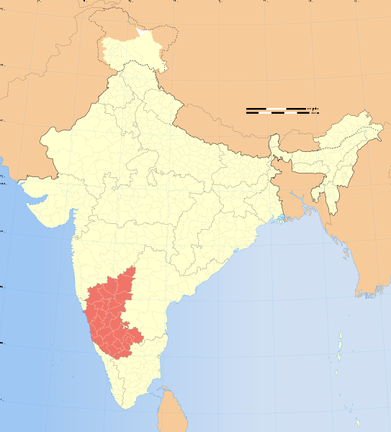

Table 4.1: Fact sheet of Karnataka

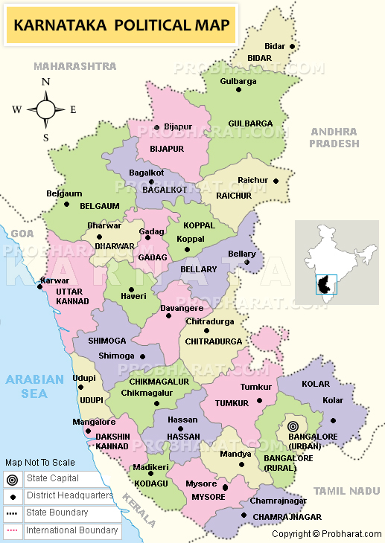

Figure 4.2: Karnataka State Map

**4.3 GOVERNMENT & ADMINISTRATION**

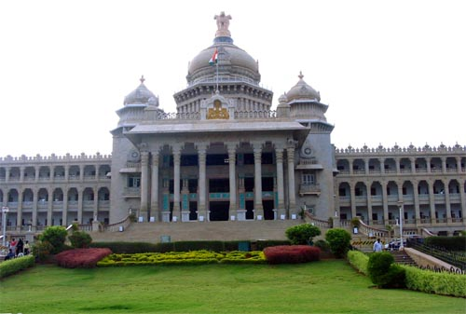

Karnataka, like other Indian states, has a parliamentary system of government with two democratically elected houses, the Legislative Assembly and the Legislative Council. The Legislative Assembly consists of 224 members who are elected for five-year terms. The Legislative Council is a permanent body of 75 members with one-third (25 members) retiring every two years.

The government of Karnataka is headed by the Chief Minister who is chosen by the ruling party members of the Legislative Assembly. The Chief Minister, along with the council of ministers, drives the legislative agenda and exercises most of the executive powers. However, the constitutional and formal head of the state is the Governor who is appointed for a five-year term by the President of India on the advice of the Union government. The people of Karnataka also elect 28 members to the Lok Sabha, the lower house of the Indian Parliament. The members of the state Legislative Assembly elect 12 members to the Rajya Sabha, the upper house of the Indian Parliament

**4.4 ECONOMY**

Karnataka, which had an estimated GSDP (Gross State Domestic Product) of about US$ 58.23 billion in 2008-09 fiscal year. Karnataka recorded the highest growth rates in terms of GDP and per capita GDP in the last decade compared to other states.

The state registered a GSDP growth rate of 7% for the year 2007-2008.] Karnataka's contribution to India's GDP in the year 2004-05 was 5.2%. Karnataka was the fastest growing state over the past decade in terms of GDP and per capital GDP . With GDP growth of 56.2% and per capita GDP growth of 43.9%, Karnataka now has the sixth highest per-capita GDP of all states. Till September 2006 Karnataka received a Foreign Direct Investment of [](http://en.wikipedia.org/wiki/File:Indian_Rupee_symbol.svg)78.097 billion ($ 1.7255 billion) for the fiscal year 2006-07, placing it third among the states of India. At the end of 2004, the unemployment rate in Karnataka was 4.94% compared to the national rate of 5.99%. For the fiscal year 2006-07, the inflation rate in Karnataka was 4.4%, compared to the national average of 4.7%. As of 2004-05, Karnataka had an estimated poverty ratio of 17%, less than the national ratio of 27.5%.

Nearly 56% of the workforce in Karnataka is engaged in agriculture and related activities. A total of 12.31 million hectares of land, or 64.6% of the state's total area, is cultivated. Much of the agricultural output is dependent on the southwest monsoon as only 26.5% of the sown area is irrigated

Karnataka is the manufacturing hub for some of the largest public sector industries in India, including Hindustan Aeronautics Limited, [National Aerospace Laboratories](http://en.wikipedia.org/wiki/National_Aerospace_Laboratories), Bharat Heavy Electricals Limited, Indian Telephone Industries, [Bharat Earth Movers Limited](http://en.wikipedia.org/wiki/Bharat_Earth_Movers_Limited) and [Hindustan Machine Tools](http://en.wikipedia.org/wiki/Hindustan_Machine_Tools), which are based in Bangalore. Many of India's premier science and technology research centers, such as [Indian Space Research Organization](http://en.wikipedia.org/wiki/Indian_Space_Research_Organization), [Central Power Research Institute](http://en.wikipedia.org/wiki/Central_Power_Research_Institute), [Bharat Electronics Limited](http://en.wikipedia.org/wiki/Bharat_Electronics_Limited) and the Central Food Technological Research Institute, are also headquartered in Karnataka. [Mangalore Refinery and Petrochemicals Limited](http://en.wikipedia.org/wiki/MRPL) is an [oil refinery](http://en.wikipedia.org/wiki/Oil_refinery) located in Mangalore.

Since the 1980s, Karnataka has emerged as the pan-Indian leader in the field of IT ([information technology](http://en.wikipedia.org/wiki/Information_technology)). As of 2007, there were nearly 2,000 firms operating out of Karnataka. Many of them, including two of India's biggest software firms, [Infosys](http://en.wikipedia.org/wiki/Infosys) and [Wipro](http://en.wikipedia.org/wiki/Wipro) are also headquartered in the state. Exports from these firms exceeded [](http://en.wikipedia.org/wiki/File:Indian_Rupee_symbol.svg)50,000 crores ($12.5 billion) in 2006-07, accounting for nearly 38% of all IT exports from India. The [Nandi Hills](http://en.wikipedia.org/wiki/Nandi_Hills,_India) area in the outskirts of [Devanahalli](http://en.wikipedia.org/wiki/Devanahalli) is the site of the upcoming $22 Billion, 50 square kilometer [BIAL IT Investment Region](http://en.wikipedia.org/wiki/BIAL_IT_Investment_Region), one the largest infrastructure projects in the history of Karnataka. All this has earned the state capital, Bangalore, the sobriquet [Silicon Valley of India](http://en.wikipedia.org/wiki/Silicon_Valley_of_India).

[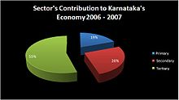](http://en.wikipedia.org/wiki/File:GSDP.JPG)

[](http://en.wikipedia.org/wiki/File:GSDP.JPG)

Figure 4.3: Economy of Karnataka

Karnataka also leads the nation in [biotechnology](http://en.wikipedia.org/wiki/Biotechnology). It is home to India's largest biocluster, with 158 of the country's 320 biotechnology firms being based here. The state also accounts for 75% of India's [floriculture](http://en.wikipedia.org/wiki/Floriculture), an upcoming industry which supplies flowers and ornamental plants worldwide.

Seven of India's leading banks, [Canara Bank](http://en.wikipedia.org/wiki/Canara_Bank), [Syndicate Bank](http://en.wikipedia.org/wiki/Syndicate_Bank), [Corporation Bank](http://en.wikipedia.org/wiki/Corporation_Bank), [Vijaya Bank](http://en.wikipedia.org/wiki/Vijaya_Bank), [Karnataka Bank](http://en.wikipedia.org/wiki/Karnataka_Bank), [Vysya Bank](http://en.wikipedia.org/w/index.php?title=Vysya_Bank&action=edit&redlink=1) and the [State Bank of Mysore](http://en.wikipedia.org/wiki/State_Bank_of_Mysore) originated in this state. The coastal districts of [Udupi](http://en.wikipedia.org/wiki/Udupi) and [Dakshina Kannada](http://en.wikipedia.org/wiki/Dakshina_Kannada) have a branch for every 500 persons—the best distribution of banks in India. As of March 2002, Karnataka had 4767 branches of different banks with each branch serving 11,000 persons, which is lower than the national average of 16,000.

A majority of the 3500 crore silk industry in India is headquartered in Karnataka State, particularly in the North Bangalore regions of [Muddenahalli](http://en.wikipedia.org/wiki/Muddenahalli), [Kanivenarayanapura](http://en.wikipedia.org/wiki/Kanivenarayanapura), and [Doddaballapura](http://en.wikipedia.org/wiki/Doddaballapura) the upcoming sites of a 70 crore "Silk City"

**CHAPTER 5**

**REQUIREMENT SPECIFICATION**

**CHAPTER 5**

**REQUIREMENT SPECIFICATION**

**5.1 GLOBAL POSITIONING SYSTEM**

The Global Positioning System (GPS) is a space-based global navigation satellite system (GNSS) that provides reliable location and time information in all weather and at all times and anywhere on or near the Earth when and where there is an unobstructed line of sight to four or more GPS satellites. It is maintained by the United States government and is freely accessible by anyone with a GPS receiver.

GPS was created and realized by the U.S. Department of Defense (USDOD) and was originally run with 24 satellites. It was established in 1973 to overcome the limitations of previous navigation systems.



Figure 5.1.Showing the GPS Satellites revolving around the Earth

**5.1.1. BASIC CONCEPTS OF GIS**

A GPS receiver calculates its position by precisely timing the signals sent by GPS satellites high above the Earth. Each satellite continually transmits messages that include

* the time the message was transmitted
* precise orbital information (the ephemeris)
* the general system health and rough orbits of all GPS satellites (the almanac).

The receiver uses the messages it receives to determine the transit time of each message and computes the distance to each satellite. These distances along with the satellites‘locations are used with the possible aid of trilateration, depending on which algorithm is used, to compute the position of the receiver. This position is then displayed, perhaps with a moving map display or latitude and longitude; elevation information may be included. Many GPS units show derived information such as direction and speed, calculated from position changes.

Three satellites might seem enough to solve for position since space has three dimensions and a position near the Earth‘s surface can be assumed. However, even a very small clock error multiplied by the very large speed of light — the speed at which satellite signals propagate — results in a large positional error. Therefore receivers use four or more satellites to solve for the receiver‘s location and time. The very accurately computed time is effectively hidden by most GPS applications, which use only the location. A few specialized GPS applications do however use the time; these include time transfer, traffic signal timing, and synchronization of cell phone base stations.

Although four satellites are required for normal operation, fewer apply in special cases. If one variable is already known, a receiver can determine its position using only three satellites. For example, a ship or aircraft may have known elevation. Some GPS receivers may use additional clues or assumptions (such as reusing the last known altitude, dead reckoning, inertial navigation, or including information from the vehicle computer) to give a less accurate (degraded) position when fewer than four satellites are visible.

**5.1.2. LATITUDE & LONGITUDE**

Latitude and longitude are angles that uniquely define points on a sphere. Together, the angles comprise a coordinate scheme that can locate or identify geographic positions on the surfaces of planets such as the earth.

**  **

Figure 5.2.Showing the Imaginary lines of Latitude and Longitude.

Latitude is defined with respect to an equatorial reference plane. This plane passes through the center *C* of the sphere, and also contains the great circle representing the equator. The latitude of a point *P* on the surface is defined as the angle that a straight line, passing through both *P* and *C* , subtends with respect to the equatorial plane. If *P* is above the reference plane, the latitude is positive (or northerly); if *P* is below the reference plane, the latitude is negative (or southerly). Latitude angles can range up to +90 degrees (or 90 degrees north), and down to -90 degrees (or 90 degrees south). Latitudes of +90 and -90 degrees correspond to the north and south geographic poles on the earth, respectively.

Longitude is defined in terms of meridians, which are half-circles running from pole to pole. A reference meridian, called the prime meridian, is selected, and this forms the reference by which longitudes are defined. On the earth, the prime meridian passes through Greenwich, England; for this reason it is also called the Greenwich meridian. The longitude of a point *P* on the surface is defined as the angle that the plane containing the meridian passing through *P* subtends with respect to the plane containing the prime meridian. If *P* is to the east of the prime meridian, the longitude is positive; if *P* is to the west of the prime meridian, the longitude is negative. Longitude angles can range up to +180 degrees (180 degrees east), and down to -180 degrees (180 degrees west). The +180 and -180 degree longitude meridians coincide directly opposite the prime meridian.

Latitude is measured from the equator, with positive values going north and negative values going south. Longitude is measured from the Prime Meridian (which is the longitude that runs through Greenwich, England), with positive values going east and negative values going west. So, for example, 65 degrees west longitude, 45 degrees north latitude is -65 degrees longitude, +45 degrees latitude.



Figure5.3. Showing the X & Y Co-ordinate system for Latitude & Longitude.

**5.2. MATERIALS**

**1. Data Requirement:** The following data are collected for proceeding with the project.

a) Collection of topographic maps : (1:50000 Scale) of the study area from survey of India, Bangalore, Map No 57 D/11 Published in 1978 and surveyed during 1972-73.

b) Scanning the above map with A0 scanner and digitizing the same.

c) Collection of panchromatic high spatial resolution (2.5m) CARTOSAT images from NRSA Hyderabad.

d) Collection of ward map from Mysore city Corporation.

e) Collection of hospital details like name, address, contact number, departments, doctors and facilities.

f) Collection of geographical co-ordinates i.e. latitudes and longitudes using GPS device by field survey of all the hospitals, blood banks, diagnostic centers and tourist spots.

g) Software – OPS GIS

h) Population data and Power data

**5.3. INTEGRATION**

a) Geo-reference the topographic sheet and other images with the necessary co-ordinate system and projection system. In this project spherical co-ordinate system, UTM projection system and WGS Datum is considered.

b) Generate the road and railway network by rasterisation of the line feature from the respective maps.

c) Design the data base of Power generating stations, departments, facilities and engineers with the required relationship and queries.

d) OPS GIS software is being used for all the above works and the database is generated using Microsoft access.

e) Both these technologies are combined to identify the shortest path with SQL and spatial query.

f) Buffer analysis is also carried to identify the NEW locations for establishing the power station depending on the demographical criteria.

g) SQL and Spatial query is used to find the nearest medical service by giving the Name of PowerStation, type of power station and Location.

**CHAPTER 6**

**PROJECT FUNCTIONALITY**

**CHAPTER 6**

**PROJECT FUNCTIONALITY**

The project can be implemented in the real time environment. It is useful for the general public and tourists and can be used as a tool for locating the required facility with a specific query. It will be very much useful in gathering information about power generation and consumption of the state. The methodology is not only useful for Power sector but also for other services like tourism, real time traffic update, tourist destination, areas of interest. The database which is merged with geographical co ordinates can be interlinked with latest mobile technology so that with a trigger from the location of the user can easily identify the nearest facility and reach the place so that the life of a person can be saved.

Since independence, we have increased our installed power capacity from 1362 MW to about 110,000 MW and electrified more than 500,000 villages. However, it is a matter of concern that the annual per capita consumption, at about 350 kWh is among the lowest in the world and there are widespread shortages of power in almost all parts of the country.

A large number of villages have no access to electricity at all. Households, farmers, commercial establishments and industries are confronted with frequent power cuts, both scheduled and unscheduled. Power cuts, erratic voltage levels and wide fluctuations in the frequency are common. Transmission and Distribution (T&D) losses, excluding theft, are as high as 27.8%. In fact, electricity theft alone causes state utilities to lose over Rs 20,000 crores annually. To make matter worse only 55% of energy generated is billed and a much lesser 41% is realized in revenues.

Hence the traditional methods have proved inefficient in power management and we require new ways to manage power efficient and effectively, hence this Project is based on GIS (Geographic Information systems) to introduce and explain how GIS can be used for **POWER MANAGEMENT FOR STATE OF KARNATAKA**.

The satellite maps, Base maps from survey of India and the ward map of the city are analyzed to form the existing road net work and a provision for upgrading the same. The database of all hospital with their services is designed with geographical co ordinates which is a most important parameter of the project. The mobile technology can be interlaced with the GIS database for the real time application.

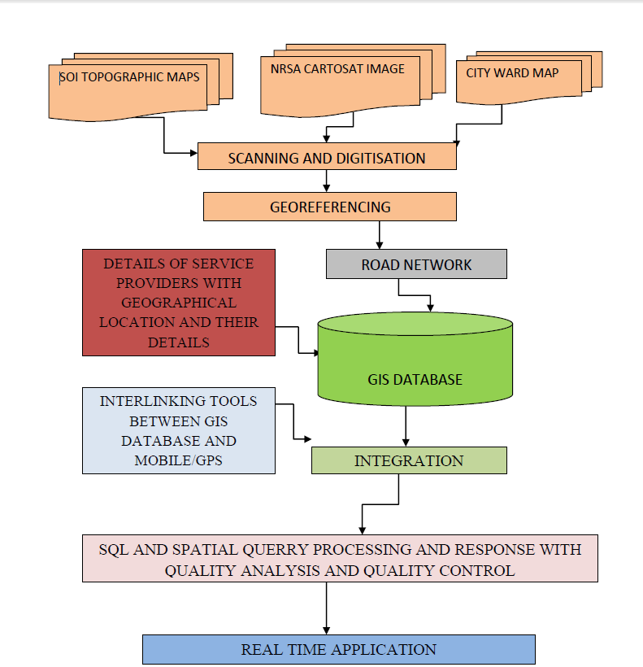

Figure 6.1 Schematic diagram of various modules adopted in the methodology.

**6.1. OBJECTIVES:**

With the advancement in technology and GIS field the scope of GIS for Power supply management is vast.

GIS for Power systems can be used for:

* Load forecasting  
   1. Load growth of the geographical area served by substation  
   2. Determination of load magnitude and its geographic location  
   3. Customer load characteristic
* Design of secondary system (low voltage distribution network)  
   1. Optimal substation allocation and transformer sizing  
   2. Secondary circuitry routing and sizing.
* Design of primary system (medium voltage distribution network)  
   1. Optimal substation allocation  
   2. Primary circuitry routing and sizing

Hence making supply of power to the state more efficient and reducing power theft and cuts.

**CHAPTER 7**

**IMPLEMENTATION**

**CHAPTER 7**

**IMPLEMENTATION**

**7.1. SOFTWARE – OPSGIS :**

Which can meet the requirements of the professional GIS users by providing tools to build and manage a complete GIS, is a powerful desktop mapping and GIS software tool? As an analysis and management tool aiming for spatial information, OPSGIS 5 has been successfully applied to many industrial fields such as land, forestry, power, telecom, traffic, environment, planning, travel, water conservancy, aviation, etc. OPSGIS is a comprehensive GIS soft for data management, visualization, modeling, and analysis, and it includes:

|  |  |
| --- | --- |
| **Module** | **Description** |
|  |  |
| **IDE(Integrated Desktop Environment)** | Provides the basic management for workspace, datasource, dataset, map, 3D scene and resources, and the advanced functionality for workspace manage window and dataset. |
| **Map** | Provides a rich set of tools which allow users to easily build high-quality maps in many different styles; includes the basic map operations for browsing maps, creating various types of thematic maps, querying maps, etc. |
| **Edit** | Provides sophisticated, CAD-like tools which help users create and edit geographic data as well as tabular data while maintaining the spatial integrity of the GIS data. |
| **Table** | Provides flexible tools for inspecting, editing, updating, maintaining, the attribute data in the attribute table. |
| **Registration** | Provides a unique registration environment for vector data and raster data. |
| **Layout** | Provides a page-centric and “what you see, what you get” layout that allow users to print quickly high-quality maps. |
| **3D Analysis** | Provides a highly dynamic environment for 3D visualization and analysis working with large and varied GIS data. |
| **Grid Analysis** | Provides a broad range of powerful cell-based analysis function that allow users to quickly derive the information you need from the GRID |
| **Network Analysis** | Provides a well-defined framework for network-based spatial analysis . |

Table 7.2 Vaious Modules Of GIS-OPS

**7.2. GEO-REFERENCE**

To georeference something means to define its existence in physical space. That is, establishing its location in terms of map projections or coordinate systems. The term is used both when establishing the relation between raster or vector images and coordinates but also when determining the spatial location of other geographical features. Examples would include establishing the correct position of an aerial photograph within a map or finding the geographical coordinates of a place name or street address. This procedure is thus imperative to data modeling in the field of geographic information systems (GIS) and other cartographic methods. When data from different sources need to be combined and then used in a GIS application, it becomes essential to have a common referencing system. This is brought about by using various georeferencing techniques. Most georeferencing tasks are undertaken either because the user wants to produce a new map or because they want to link two or more different datasets together by virtue of the fact that they relate to the same geographic locations.

In this project, OPS-GIS is used to register the toposheet with registration tools selecting the four corner points of the toposheet given the value as follows.

Inserting spatial data for particular point in map is shown below:

* A point is selected in the map that is to be geo-referenced is selected using appropriate tools as shown below.

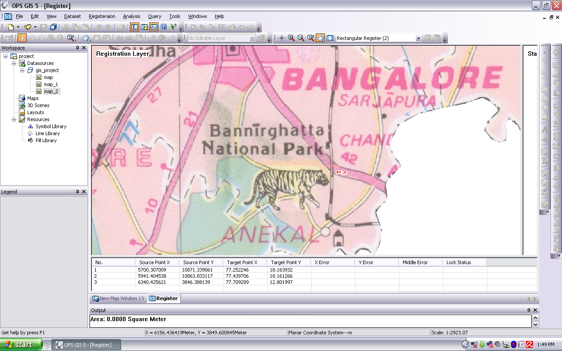

Figure 7.2: Selecting a point on the Political map

* To achieve this we obtain the Exact X (Longitude) and Y (Latitude) Coordinates are obtained by searching for the point using various GIS software/tools, in this case we use Google Earth.

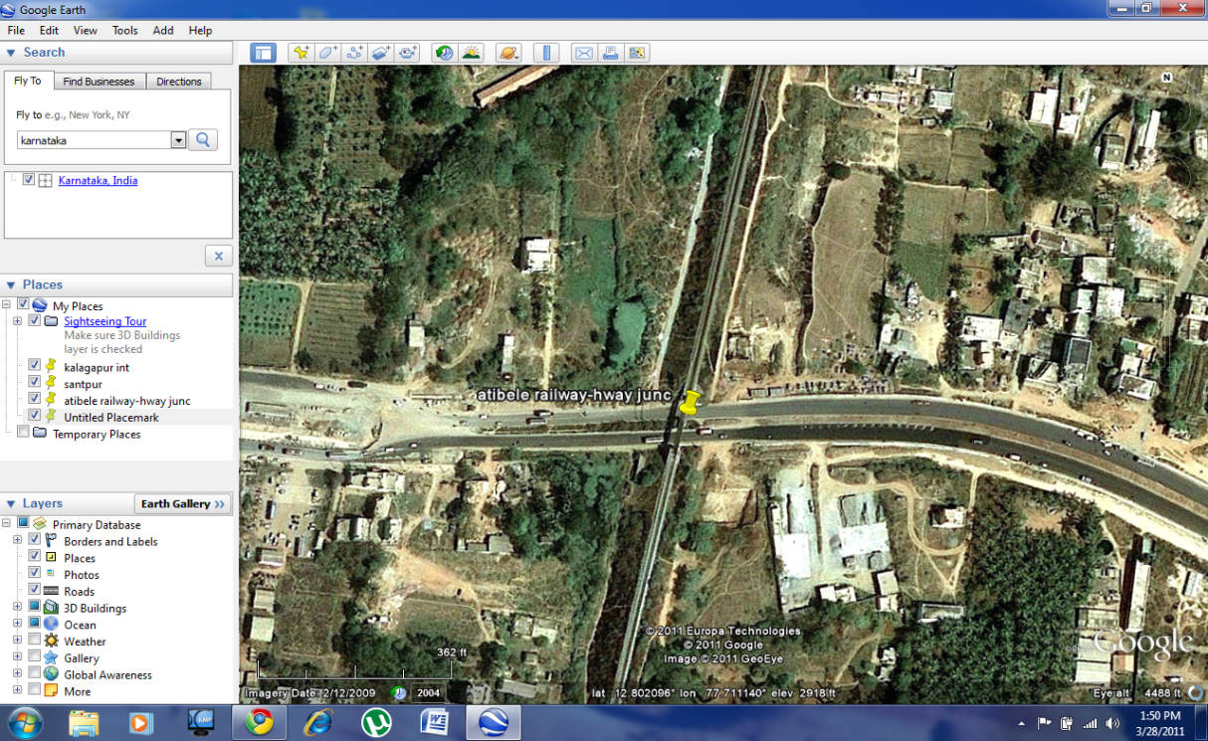

Figure 7.3: Selecting a point on Google Earth

* Once we have obtained the X and Y Coordinates we enter the data into the GIS Software as shown below and we calculate the Middle Error such that it is less than 0.

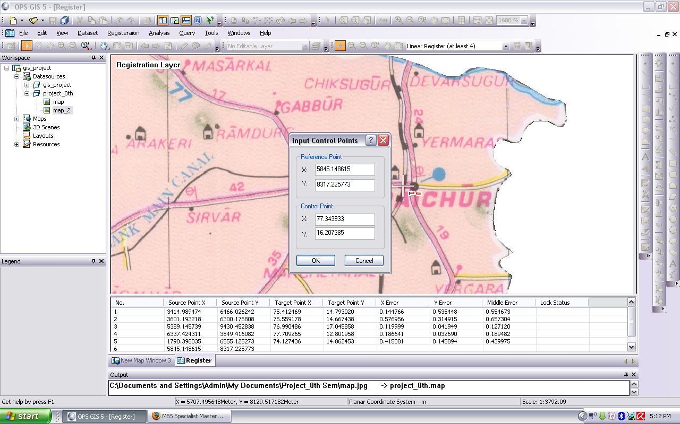

Figure 7.4: Entering the coordinates

**7.3. DIGITIZATION :**

Digitizing is the process of making features we can see on the map and making them features to which additional spatial and non-spatial attributes can be assigned. This means we are going to follow a process of making digital versions of objects that will have an attribute table associated with them. Our primary goal will be digitizing the state and district boundaries, which are objects that occupy an area on the map, once they are digitized and have an associated attribute table these objects will also be known as polygon features. In an accompanying document you have data on the Karnataka state district wise. When digitizing we can digitize points, lines, or polygons. By digitizing these features, you make them available for mapping once you have added the tabular data to the attribute table (as you know there are a few ways you can do this).

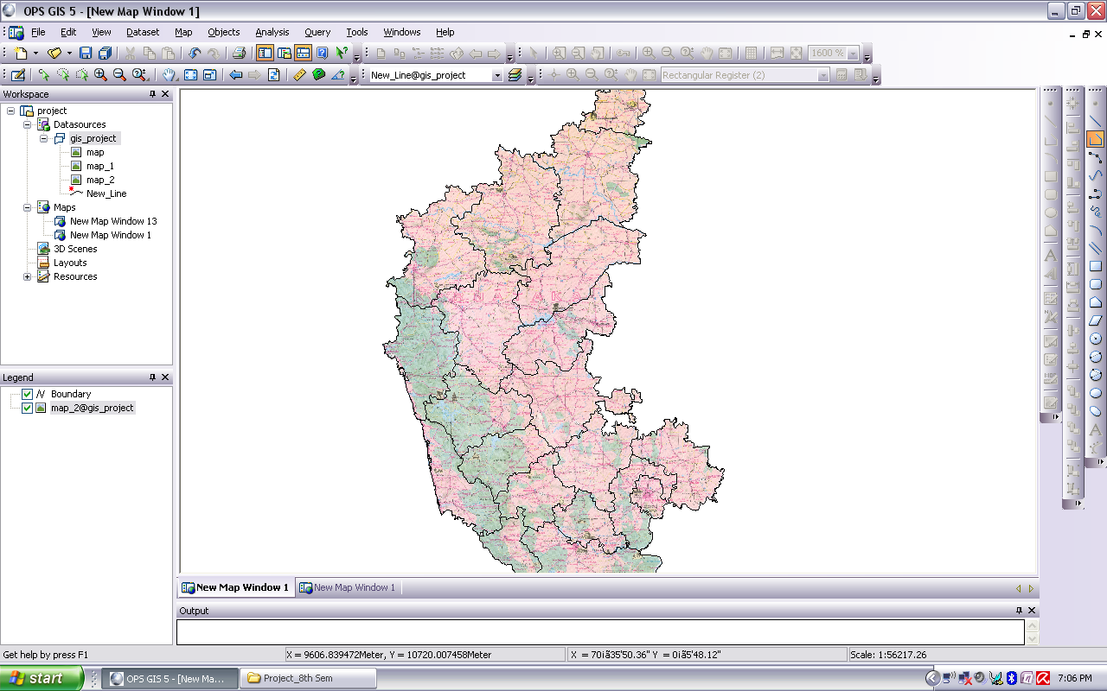

Figure 7.5: Digitizing the Political map

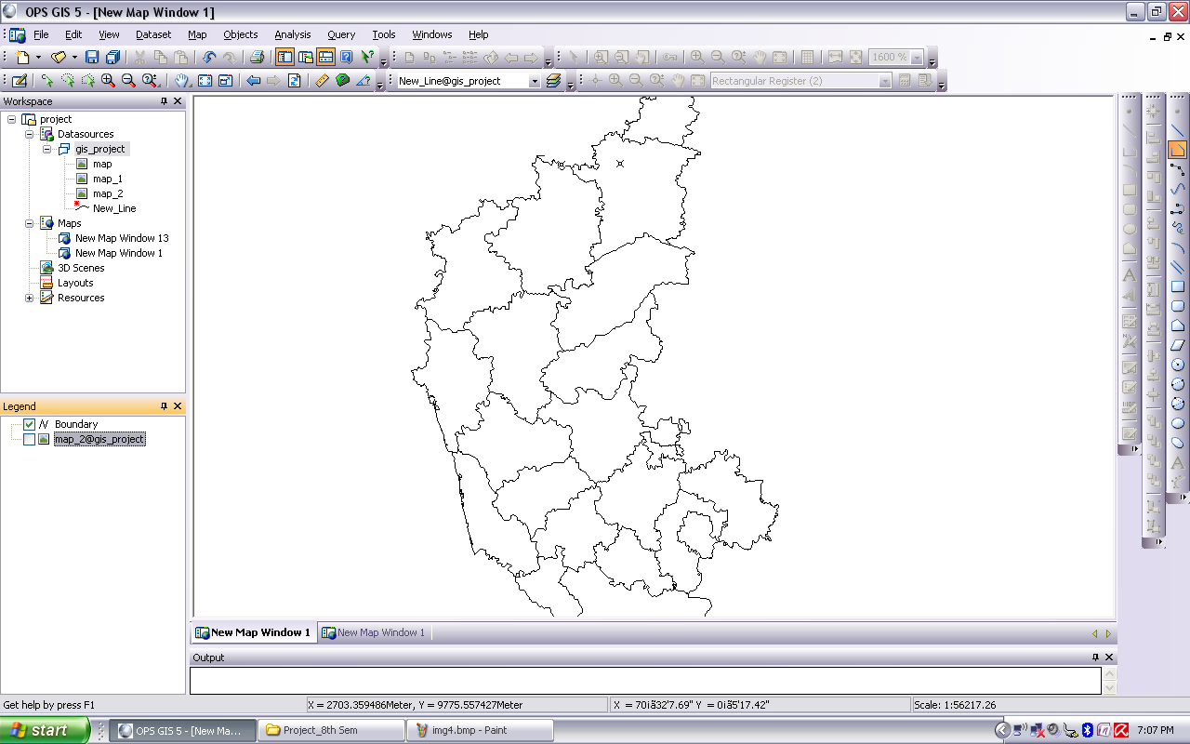

Figure 7.6: Digitized Map

**7.4.** **MAP PROJECTION**

A map projection is any method of representing the surface of a sphere or other three-dimensional body on a plane. Map projections are necessary for creating maps. All map projections distort the surface in some fashion. Depending on the purpose of the map, some distortions are acceptable and others are not; therefore different map projections exist in order to preserve some properties of the sphere-like body at the expense of other properties. There is no limit to the number of possible map projections.

A fundamental projection classification is based on the type of projection surface onto which the globe is conceptually projected. The projections are described in terms of placing a gigantic surface in contact with the earth, followed by an implied scaling operation. These surfaces are cylindrical (e.g. Mercator), conic (e.g., Albers), or azimuthal or plane (e.g. stereographic). Many mathematical projections, however, do not neatly fit into any of these three conceptual projection methods. Hence other peer categories have been described in the literature, such as pseudo conic, pseudo cylindrical, pseudoazimuthal, retroazimuthal, and polyconic.

Another way to classify projections is according to properties of the model they preserve. Some of the more common categories are:

* Preserving direction (azimuthal), a trait possible only from one or two points to every other point
* Preserving shape locally (conformal or orthomorphic)
* Preserving area (equal-area or equiareal or equivalent or authalic)
* Preserving distance (equidistant), a trait possible only between one or two points and every other point
* Preserving shortest route, a trait preserved only by the gnomonic projection

**7.5. CO-ORDINATE SYSTEM**

In geometry, a coordinate system is a system which uses one or more numbers, or coordinates, to uniquely determine the position of a point or other geometric element. The order of the coordinates is significant and they are sometimes identified by their position in an ordered tuple and sometimes by a letter, as in 'the x-coordinate'. In elementary mathematics the coordinates are taken to be real numbers, but in more advanced applications coordinates can be taken to be complex numbers or elements of a more abstract system such as a commutative ring. The use of a coordinate system allows problems in geometry to be translated into problems about numbers and vice versa; this is the bases of analytic geometry.

An example in everyday use is the system of assigning longitude and latitude to geographical locations.

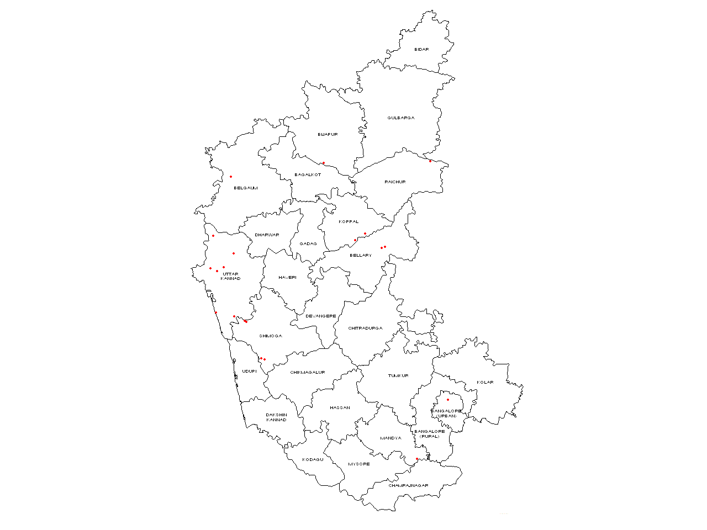

Figure 7.7: State Map of Karnataka with Power stations

**7.6. DATABASE DESIGN USING MICROSOFT ACCESS**

The data base is designed by collecting all the information about the hospitals like name of the hospital, address, facilities, doctors, services, blood bank, diagnostic center, departments etc.,

Relations are created using the primary key and foreign key like which department is available in different hospital, which doctor of specific department is available in which hospital etc., with latitude and longitude as the ‘x‘ and ‘y‘ co ordinates.

The following tables were created with the relationship as shown.

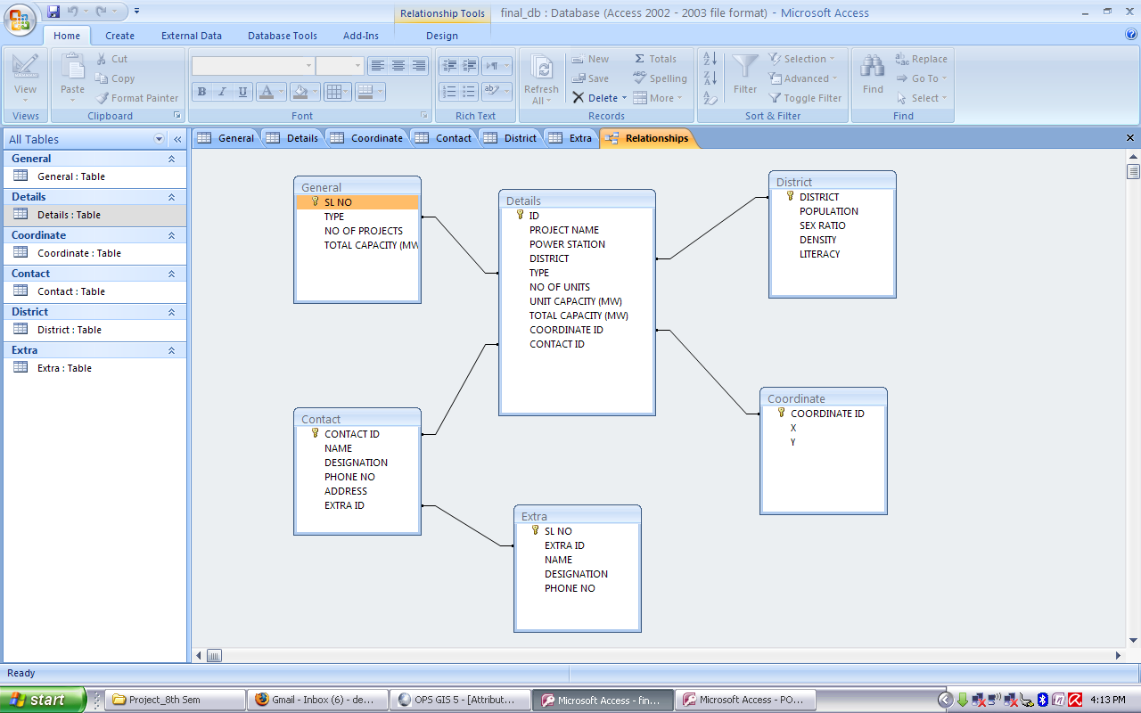

Figure 7.8: Database relation of PowerStation

Convert the .accdb file to .mdb file and import the file to the OPS-GIS software and convert the attribute data to point source so that the hospital and other locations are shown on the map.

**7.6.1 SNAPSHOTS OF THE DATABASES**

| **General** | | | |
| --- | --- | --- | --- |
| **SL NO** | **TYPE** | **NO OF PROJECTS** | **TOTAL CAPACITY (MW)** |
| 1 | HYDEL | 21 | 3636.75 |
| 2 | THERMAL | 6 | 3788 |
| 3 | SOLAR | 2 | 6 |
| 4 | WIND | 1 | 4.56 |
| 5 | NUCLEAR | 1 | 880 |

Table 7.2: General Database

| **Details** | | | | | | | | | |
| --- | --- | --- | --- | --- | --- | --- | --- | --- | --- |
| **ID** | **PROJECT NAME** | **POWER STATION** | **DISTRICT** | **TYPE** | **NO OF UNITS** | **UNIT CAPACITY (MW)** | **TOTAL CAPACITY (MW)** | **COORDINATE** | **CONTACT** |
| 1 | RTPS | Raichur Thermal Power Plant | RAICHUR | THERMAL | 7+1 | 210+250 | 1720 | XY1 | C1 |
| 2 | BTPS | Bellary Thermal Power Plant | BELLARY | THERMAL | 1 | 500 | 500 | XY2 | C2 |
| 3 | UTPS | Udupi Thermal Power Plant | UDUPI | THERMAL | 1 | 600 | 600 | XY3 | C3 |
| 4 | JSW EL-SBU-I | JSW EL-SBU-I | - | THERMAL | 2 | 130 | 260 | XY4 | C4 |
| 5 | JSW EL-SBU-II | JSW EL-SBU-II | - | THERMAL | 2 | 300 | 600 | XY5 | C5 |
| 6 | Yelahanka-Diesel | Yelahanka | BANGALORE | THERMAL | 6 | 18 | 108 | XY6 | C6 |
| 7 | Sharvathy Project | Linganamakki | SHIMOGA | HYDEL | 2 | 27.5 | 55 | XY7 | C7 |
| 8 | Sharvathy Project | Sharavathi | SHIMOGA | HYDEL | 10 | 103.5 | 1035 | XY8 | C8 |
| 9 | Sharvathy Project | Gerusoppa | SHIMOGA | HYDEL | 4 | 60 | 240 | XY9 | C9 |
| 10 | Sharvathy Project | Mahatma Gandhi Jog | SHIMOGA | HYDEL | 4+4 | 21.6+13.2 | 139 | XY10 | C10 |
| 11 | Sharvathy Project | Bhadra Left Bank | SHIMOGA | HYDEL | 2+1 | 12+2 | 26 | XY11 | C11 |
| 12 | Sharvathy Project | Bhadra Right Bank | SHIMOGA | HYDEL | 1+1 | 7.2+6 | 13 | XY12 | C12 |
| 13 | Kalinadi Project | Supa | KARWAR | HYDEL | 2 | 50 | 100 | XY13 | C13 |
| 14 | Kalinadi Project | Nagjhari | KARWAR | HYDEL | 2+4 | 135+150 | 870 | XY14 | C14 |
| 15 | Kalinadi Project | Kadra | KARWAR | HYDEL | 3 | 50 | 150 | XY15 | C15 |
| 16 | Kalinadi Project | Kodasalli | KARWAR | HYDEL | 3 | 40 | 120 | XY16 | C16 |
| 17 | Varahi Project | Varahi | SHIMOGA | HYDEL | 4 | 115 | 460 | XY17 | C17 |
| 18 | Varahi Project | Mani | SHIMOGA | HYDEL | 2 | 4.5 | 9 | XY18 | C18 |
| 19 | Mini-Hydel | Almatti | BIJAPUR | HYDEL | 1+5 | 15+55 | 290 | XY19 | C19 |
| 20 | Mini-Hydel | Shivanasamudram | MANDYA | HYDEL | 4+6 | 6+3 | 42 | XY20 | C20 |
| 21 | Mini-Hydel | Shishma | TUMKUR | HYDEL | 2 | 8.6 | 17 | XY21 | C21 |
| 22 | Mini-Hydel | Munirabad | BELLARY | HYDEL | 2+1 | 9+10 | 28 | XY22 | C22 |
| 23 | Mini-Hydel | Ghataprabha | BELGAUM | HYDEL | 2 | 16 | 32 | XY23 | C23 |
| 24 | Mini-Hydel | Mallapur | RAICHUR | HYDEL | 2 | 4.5 | 9 | XY24 | C24 |
| 25 | Mini-Hydel | Sirwar | RAICHUR | HYDEL | 1 | 1 | 1 | XY25 | C25 |
| 26 | Mini-Hydel | Kalmala | RAICHUR | HYDEL | 1 | .4 | .4 | XY26 | C26 |
| 27 | Mini-Hydel | Genekal | RAICHUR | HYDEL | 1 | .35 | .35 | XY27 | C27 |
| 28 | Wind Power | Kappadagudda | GADAG | WIND | 9+11 | .225+.23 | 5 | XY28 | C28 |
| 29 | Solar power | Yalesandra Solar PV Plant, Kolar | KOLAR | SOLAR | 1 | 3 | 3 | XY29 | C29 |
| 30 | Solar Power | Itnal Solar PV Plant, Belgaum | BELGAUM | SOLAR | 1 | 3 | 3 | XY30 | C30 |
| 31 | KNPT | Kaiga Nuclear Power Plant | KAIGA | NUCLEAR | 4 | 220 | 880 | XY31 | C31 |

Table 7.3: Database view of power station in detail

| **Coordinate** | | |
| --- | --- | --- |
| **COORDINATE ID** | **X** | **Y** |
| XY1 | 77.343333 | 16.355555 |
| XY10 | 74.815177 | 14.191637 |
| XY11 | 74.814673 | 14.192349 |
| XY12 | 74.814673 | 14.192349 |
| XY13 | 74.391666 | 15.346944 |
| XY14 | 74.668919 | 15.1084052 |
| XY15 | 74.355277 | 14.899166 |
| XY16 | 74.535277 | 14.919444 |
| XY17 | 75.084722 | 13.663611 |
| XY18 | 75.045555 | 13.676111 |
| XY19 | 75.888866 | 16.339910 |
| XY2 | 76.721111 | 15.193611 |
| XY20 | 77.164722 | 12.307778 |
| XY21 | 0 | 0 |
| XY22 | 76.317777 | 15.283333 |
| XY23 | 74.633333 | 16.15 |
| XY24 | 76.45861 | 15.3775 |
| XY25 | 0 | 0 |
| XY26 | 0 | 0 |
| XY27 | 0 | 0 |
| XY28 | 0 | 0 |
| XY29 | 0 | 0 |
| XY3 | 0 | 0 |
| XY30 | 0 | 0 |
| XY31 | 74.438611 | 14.864722 |
| XY4 | 76.676666 | 15.181666 |
| XY5 | 76.676666 | 15.181666 |
| XY6 | 77.583735 | 13.115403 |
| XY7 | 74.891944 | 17.121666 |
| XY8 | 74.424166 | 14.298888 |
| XY9 | 74.675555 | 14.250555 |

Table 7.4: Database view of power station coordinates

| **Contact** | | | | | |
| --- | --- | --- | --- | --- | --- |
| **CONTACT ID** | **NAME** | **DESIGNATION** | **PHONE NO** | **ADDRESS** | **EXTRA** |
| C1 | H N Narayana Prasad | Executive Director | 08532 – 246116 | KPCL, Shaktinagar – 584170 | E1 |
| C10 | Shri G Hanumanthappa | Chief Engineer | 08186-244606 | KPCL, Jog Falls – 577 435 | E10 |
| C11 | Shri G Hanumanthappa | Chief Engineer | 08186-244606 | KPCL, Jog Falls – 577 435 | E11 |
| C12 | Shri G Hanumanthappa | Chief Engineer | 08186-244606 | KPCL, Jog Falls – 577 435 | E12 |
| C13 | Shri Shashikanth | Chief Engineer | 08284 – 258625 | Karnataka Power Corporation Limited,Ambikanagar – 581363,Ganeshgudi - 581365,Kadra Colony - 581396 | E13 |
| C14 | Shri Shashikanth | Chief Engineer | 08284 – 258625 | Karnataka Power Corporation Limited,Ambikanagar – 581363,Ganeshgudi - 581365,Kadra Colony - 581396 | E14 |
| C15 | Shri Shashikanth | Chief Engineer | 08284 – 258625 | Karnataka Power Corporation Limited,Ambikanagar – 581363,Ganeshgudi - 581365,Kadra Colony - 581396 | E15 |
| C16 | Shri Shashikanth | Chief Engineer | 08284 – 258625 | Karnataka Power Corporation Limited,Ambikanagar – 581363,Ganeshgudi - 581365,Kadra Colony - 581396 | E16 |
| C17 | Shri N Ramaiah | Chief Engineer | 08259 – 288232 | Varahi Hydel Project,Karnataka Power Corporation Limited.Hosangadi – 576282,Mastikatte - 577448 | E17 |
| C18 | Shri N Ramaiah | Chief Engineer | 08259 – 288232 | Varahi Hydel Project,Karnataka Power Corporation Limited,Hosangadi – 576282,Mastikatte - 577448 | E18 |
| C19 | Shri S B Bislapur | Executive Engineer | 08231-247027 | Almatti Dam Power House,Karnataka Power Corporation Limited,Almatti - 586 201 | E19 |
| C2 | G.Rathnamma | I/cExecutive Director | 08392 – 248610 | KPCL,(Kuduthini), Bellary District - 583115 | E2 |
| C20 | Shri R K Suresh | Superintending Engineer | 08231-247027 | Karnataka Power Corporation Limited,Shivasamudram-571 437. | E20 |
| C21 | Shri R K Suresh | Superintending Engineer | 08231-247027 | Karnataka Power Corporation Limited,Shivasamudram-571 437. | E21 |
| C22 | Shri Halaswamy KN | Executive Engineer | 08539-270214 | Karnataka Power Corporation Limited, Munirabad – 583 233 | E22 |
| C23 | Shri DR Ashwathnarayana | Executive Engineer | 08333 – 286249 | Ghataprabha Hydro Electric Project,Karnataka Power Corporation Limited,Hidkal Dam –581107 | E23 |
| C24 | Shri Halaswamy KN | Executive Engineer | 08539-270214 | Karnataka Power Corporation Limited, Munirabad – 583 233 |  |
| C25 | Shri Halaswamy KN | Executive Engineer | 08539-270214 | Karnataka Power Corporation Limited, Munirabad – 583 233 |  |
| C26 | Shri Halaswamy KN | Executive Engineer | 08539-270214 | Karnataka Power Corporation,Limited, Munirabad – 583 233 |  |
| C27 | Shri Halaswamy KN | Executive Engineer | 08539-270214 | Karnataka Power Corporation,Limited, Munirabad – 583 233 |  |
| C28 | - |  |  | Karnataka Power Corporation,Limited,kappatagudda,Gadag-582103 | E28 |
| C29 | - |  |  |  |  |
| C3 | N.Ramaiah |  |  |  |  |
| C30 | - |  |  |  |  |
| C31 | G. Nageswara Rao | Chief Engineer | 08382264047 | Kaiga, District Uttar Kannada, Karnataka |  |
| C4 | - |  |  |  |  |
| C5 | - |  |  |  |  |
| C6 | Shri B.N. Sridhar | Superintending Engineer (E) | 080-28567966 | Diesel Power Generating Plant Karnataka Power Corporation Limited Yelahanka - 560064 | E6 |
| C7 | B Ramaiah | Chief Engineer(civil) | 08186240401 | Linganamakki,Shimoga | E7 |
| C8 | Shri G Hanumanthappa | Chief Engineer | 08186-244606 | KPCL, Jog Falls – 577 435 | E8 |
| C9 | Shri A Manogaran | Superintending Engineer | 08387 – 268301 | KPCL, Gerusoppa– 581 334 | E9 |

Table 7.5 Database view of power station contacts

| **District** | | | | |
| --- | --- | --- | --- | --- |
| **DISTRICT** | **POPULATION** | **SEX RATIO** | **DENSITY** | **LITERACY** |
| BAGALKOT | 1890826 | 984 | 288 | 69.39 |
| BANGALORE | 9588910 | 908 | 4378 | 88.48 |
| BANGALORE RURAL | 987257 | 945 | 441 | 78.29 |
| BELGAUM | 4778439 | 969 | 356 | 73.94 |
| BELLARY | 2532383 | 978 | 300 | 67.85 |
| BIDAR | 1700018 | 952 | 312 | 71.01 |
| BIJAPUR | 2175102 | 954 | 207 | 67.20 |
| CHAMARAJNAGAR | 1020962 | 989 | 200 | 61.12 |
| CHIKBALLAPUR | 1254377 | 968 | 441 | 78.29 |
| CHIKMAGALUR | 1137753 | 1005 | 158 | 79.24 |
| CHITRADURGA | 1660378 | 969 | 197 | 73.82 |
| DAKSHINA KANNADA | 2083625 | 1018 | 457 | 88.62 |
| DAVANGERE | 1946905 | 967 | 329 | 76.30 |
| DHARWAD | 1846993 | 967 | 434 | 80.30 |
| GADAG | 1065235 | 978 | 229 | 75.18 |
| GULBARGA | 2564892 | 962 | 233 | 65.65 |
| HASSAN | 1776221 | 1005 | 261 | 75.89 |
| HAVERI | 1598506 | 951 | 331 | 77.60 |
| KODAGU | 554762 | 1019 | 135 | 82.52 |
| KOLAR | 1540231 | 976 | 384 | 74.33 |
| KOPPAL | 1391292 | 983 | 250 | 67.28 |
| MANDYA | 1808680 | 989 | 365 | 70.14 |
| MYSORE | 2994744 | 982 | 437 | 72.56 |
| RAICHUR | 1924773 | 992 | 228 | 60.46 |
| RAMANAGARAM | 1082739 | 976 | 303 | 69.20 |
| SHIMOGA | 1755512 | 995 | 207 | 80.50 |
| TUMKUR | 2681449 | 979 | 253 | 74.32 |
| UDUPI | 1177908 | 1093 | 304 | 86.29 |
| UTTARA KANNADA | 1436847 | 975 | 140 | 84.03 |
| YADGIR | 1172985 | 984 | 224 | 52.36 |

Table 7.6: Database view of power station and corresponding districts

| **Extra** | | | | |
| --- | --- | --- | --- | --- |
| **SL NO** | **EXTRA ID** | **NAME** | **DESIGNATION** | **PHONE** |
| 1 | E1 | P Bhaskar | Chief Engineer(O&M ) | 08532 246125 |
| 2 | E2 | C Venugopal | Chief Engineer(C ) | 08392 288610 |
| 3 | E2 | T V Ranganatha | Chief Engineer(C )U-3 | 08392 288609 |
| 4 | E2 | Narendra Kumar | Chief Engineer(C,O & M ) | 08392 288602 |
| 5 | E2 | Chinna Somaiah | Superintending Engineer(C )-2 | 08392 288603 |
| 6 | E2 | Chandrakanth Dondiba | Superintending Engineer(O) | 08392 288604 |
| 7 | E1 | S Mrutyunjaya | CCET | 08532 246164 |
| 8 | E1 | Channapally Shivaraj | Chief Engineer(FM ) | 08532 246135 |
| 9 | E1 | N R K Rao | Asst.Commd CISF | 08532 246134 |
| 10 | E1 | S Rama Rao | SEO-1 | 08532 246156 |
| 11 | E6 | R Rajeshwari | Executive Engineer(E) | 080 28460974 |
| 12 | E6 | G Ramesh | Executive Engineer(M) | 080 28567962 |
| 13 | E6 | H C Prabhakar | I/c Executive Engineer(E) | 080 28567962 |
| 14 | E6 | S A Kulkarni | Executive Engineer(C ) | 9900247025 |
| 15 | E6 | B Nagaraja | Asst General Manager(F)Y | 080 28567967 |
| 16 | E7 | S L Sridhara Rao | Executive Engineer(C ) | 08186 240402 |
| 17 | E7 | K Prabhakar | Executive Engineer(C ) | 08186 240402 |
| 18 | E7 | K R Manjunath | Executive Engineer(C ) | 08186 240402 |
| 19 | E7 | M V Dayananda | Executive Engineer(C ) | 08186 240402 |
| 20 | E7 | R P Murahari | Executive Engineer(C ) | 08186 240402 |
| 21 | E8 | K R Shivaji | Superintending Engineer(E)S | 08186 244606 |
| 22 | E8 | B K Sujatha | Executive Engineer(O) | 08186 244642 |
| 23 | E8 | C D Ramareddy | Executive Engineer(E)S-1 | 9449598801 |
| 24 | E8 | Babu Rajendra Prasad | Executive Engineer(E)S-2 | 9449598802 |
| 25 | E8 | N Udaya Naik | Executive Engineer(E)S-3 | 9449598801 |
| 26 | E9 | Sudeep Rai | I/c Executive Engineer(E)-1/GP | 08387 268307 |
| 27 | E9 | S Chandrashekaraiah | Executive Engineer(E)-2/GP | 08387 268311 |
| 28 | E9 | K S Prasad | Chief Superintending Engineer | 08387 268303 |
| 29 | E9 | G N Dayanand | Executive Engineer(C ) | 08387 268303 |
| 30 | E9 | V R Patil | DMS(GP) | 08387 268305 |
| 31 | E10 | K R Shivaji | Superintending Engineer(E) | 08186 244606 |
| 32 | E10 | R Y Shirali | Executive Engineer(E) | 08186 244653 |
| 33 | E10 | Control Room |  | 08186 244653 |
| 34 | E11 | Sai Upendra Babu | Executive Engineer(E)B | 08282 292677 |
| 35 | E11 | Bhadra Control Room |  | 08282 292677 |
| 36 | E12 | Sai Upendra Babu | Executive Engineer(E)B | 08282 292677 |
| 37 | E12 | Bhadra Control Room |  | 08282 292677 |
| 38 | E15 | Vijaya Kulkarni | SEEK | 08382 256344 |
| 39 | E15 | H R Premanath | CSK | 08382 256332 |
| 40 | E15 | S N Nanjundamurthy | CKE-1 | 08382 256335 |
| 41 | E15 | D K Jagadeesh | CKE-2 | 08382 256334 |
| 42 | E15 | S V Nagesh | CKE-3 | 08382 256333 |
| 43 | E16 | R G Mathad | I/c Executive Engineer(N) | 08384 258626 |
| 44 | E16 | V Thippeswamy | D General Manager(F)K-1 | 08384 258638 |
| 45 | E16 | R Gokulananad | MS(A) | 08384 258630 |
| 46 | E16 | Mamatha Anand | DLMS | 08384 258630 |
| 47 | E16 | A Lokesh | Executive Engineer(MSP)A | 08384 258681 |
| 48 | E17 | K Kamalaksha | I/c Superintending Engineer(E)V | 08259 288232 |
| 49 | E17 | H R Ramesh | Executive Engineer(E)V-1 | 9449598840 |
| 50 | E17 | H Mohan | Executive Engineer(E)V-2 | 9449598834 |
| 51 | E17 | P K Arjunwad | Executive Engineer(MSP)H | 08259 288643 |
| 52 | E17 | J S Rajaram | Executive Engineer(C )/CAE-PH | 08259 288221 |
| 53 | E18 | S Chandragupta | CAE(D) | 08185 265307 |
| 54 | E18 | Dinesh Kumar | I/c Executive Engineer(M) | 08185 265222 |
| 55 | E18 | R A Vernekar | ASO(M) | 08185 265240 |
| 56 | E18 | Mani Dam Power House |  | 08185 294014 |
| 57 | E19 | S R Patil | Executive Engineer(C ) | 94481 36582 |
| 58 | E19 | P M Deshpande | Executive Engineer(M) | 94489 99460 |
| 59 | E19 | N B Latkan | AO | 94489 99463 |
| 60 | E19 | M M Mulla | ASO | 94489 40819 |
| 61 | E19 | ADPH Control Room |  | 08354 291049 |
| 62 | E20 | H N Manjunath | Executive Engineer(Stores) | 9900247021 |
| 63 | E20 | P L Chaithanya Prabhu | Executive Engineer(O&M) | 08231 247036 |
| 64 | E20 | H C Ravish | AO | 08231 247036 |
| 65 | E20 | Srinivasmurthy | Executive Engineer(C ) | 9449809980 |
| 66 | E20 | Devarajachar | Asst. General manager(G) | 9449599117 |
| 67 | E21 | H N Balasubrahmanya | Executive Engineer(O&M) | 08231 247804 |
| 68 | E22 | Rajavardhan | DGM(F)IA | 9448290571 |
| 69 | E22 | MDPH Control Room |  | 08539 270017 |
| 70 | E23 | Ghatprapha Dam & Power House |  | 08333 263246 |
| 71 | E23 | IB(Honnur) |  | 08333 263237 |
| 72 | E23 | IB(Hidkal) |  | 08333 263235 |
| 73 | E28 | M M Patil | Asst. Executive Engineer(M) Residence | 08372 231529 |
| 74 | E28 | M M Patil | Asst. Executive Engineer(M) Site | 08371 283397 |

Table 7.7: Database view of power station and extra information about it.

**7.7. STRUCTURED QUERY LANGUAGE**

The software provides the facility of SQL. Querying can be in the form of relationship between the parameters required as follows.

1. List the contact information of all the authorities in the power stations.
2. List out all the Power Stations in a particular District.
3. List the District information related to that power station.
4. List the Extra Contact information of all the power stations

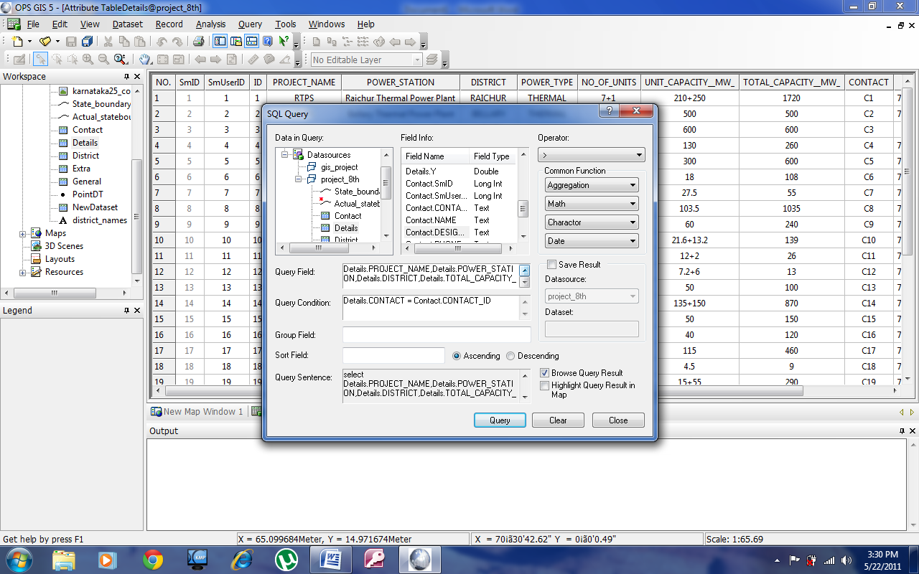

Figure 7.9 Table created based on Contact ID

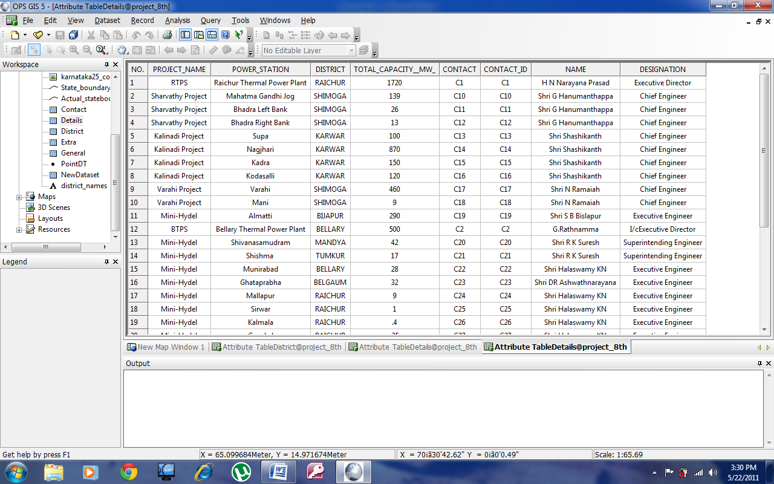

Table 7.8 Table of power stations with contact information

**CHAPTER 8**

**WEBSITE DESIGN**

**CHAPTER 8**

**WEBSITE DESIGN**

**8.1. DEVELOPMENT OF WEB PORTAL**

Based on the GIS System developed a user interactive web portal has been created, this web portal can serve as a source of knowledge and information to general public. Since the GIS system developed requires software to run and the requirements of the system cannot be met by general public this web portal serves as a means by which they can access the same information without any hassles.

The web page is a XHTML based web page and contains query fields which are written using PHP and the layout of the web page is done using Style sheets (CSS).

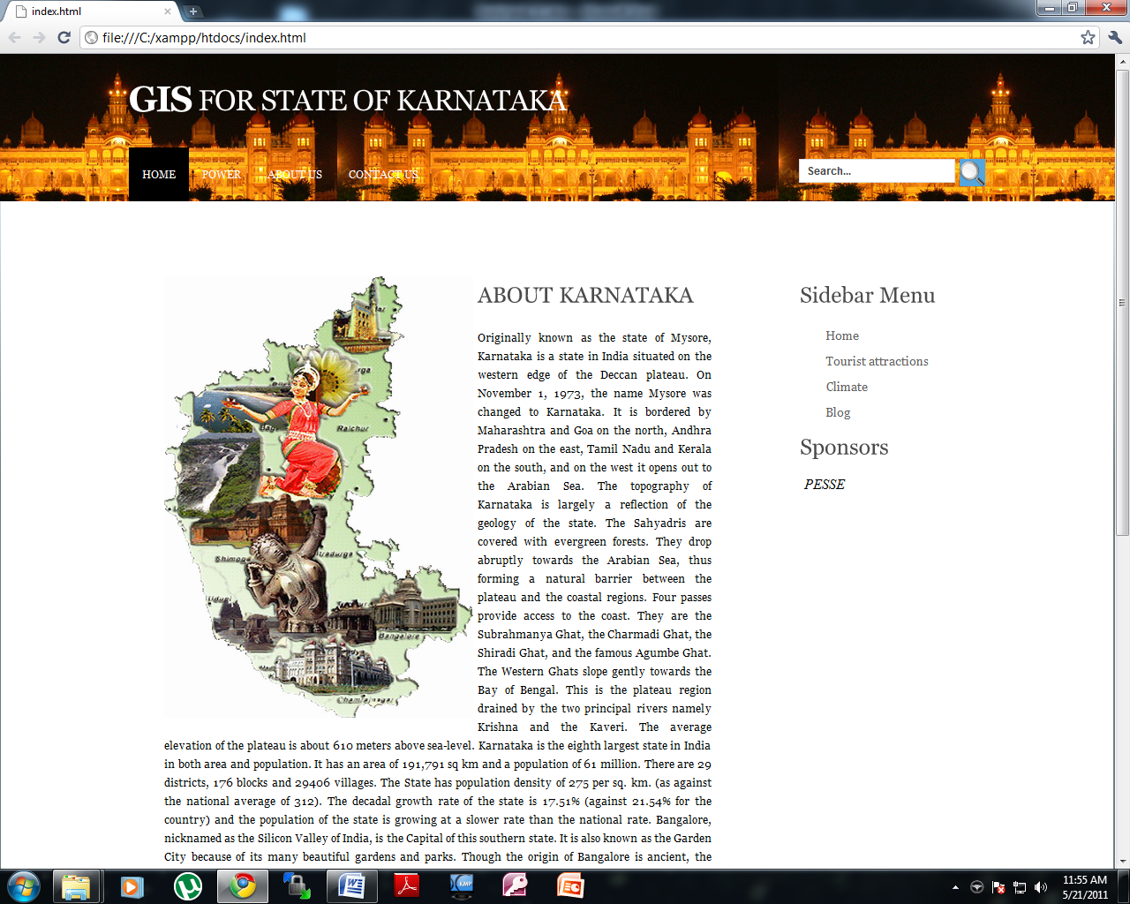

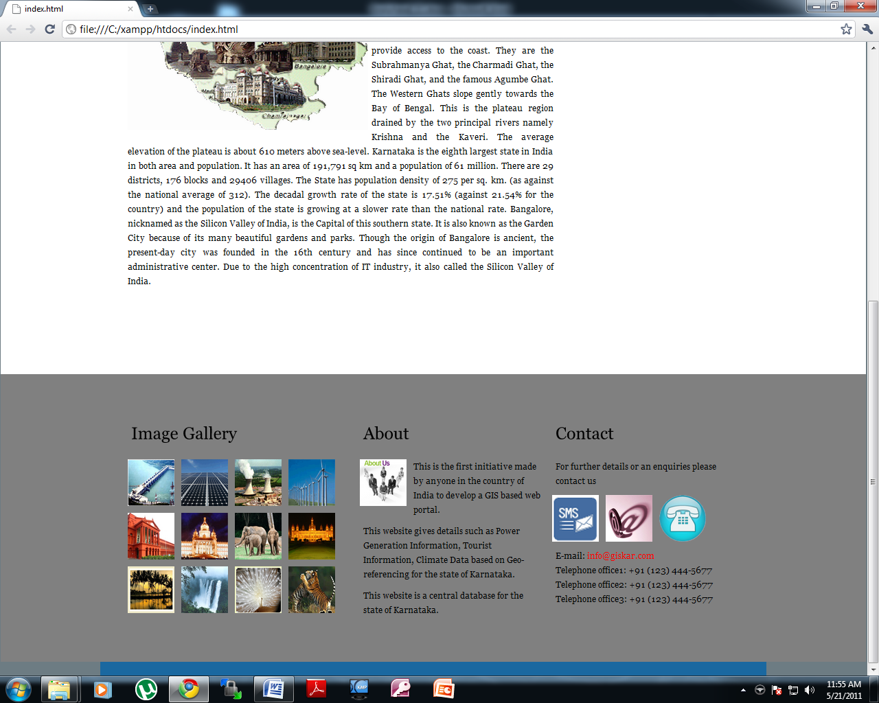

Figure 8.1 Main web Page

The Main page contains an image gallery about Karnataka and its beauty.

The GIS software system is used by the ELECTRIC BOARD and might contain sensitive data and hence this cannot be shared with general public.

The web portal serves as a mean by which people can log into the network submit feedback, lodge complaints regarding long hours of power cuts etc. also the web page can be expanded to integrate various other GIS fields such as location of hospitals, road networks ( to indicate real-time traffic ) , Bus routes , Tourist destinations and Places to stay .

The WEBPORTAL is simple and easy to use and can be expanded drastically as and when the system grows

**8.1.1 POWER TAB**

The Power tab on the web portal redirects to the Power sector and all the information that can be provided by the Karnataka Electric Board, this contains a Map of Karnataka and all the power stations in each district.

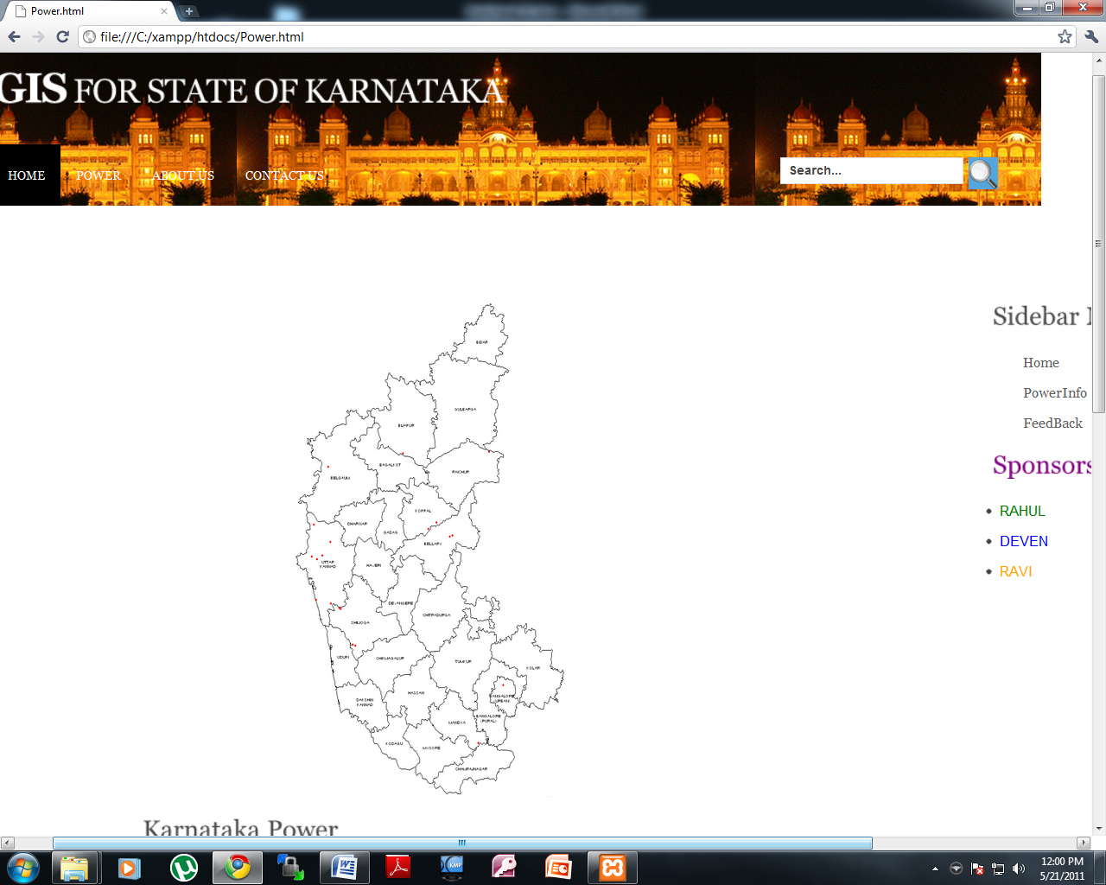

Figure 8.2 Power tab of web Page

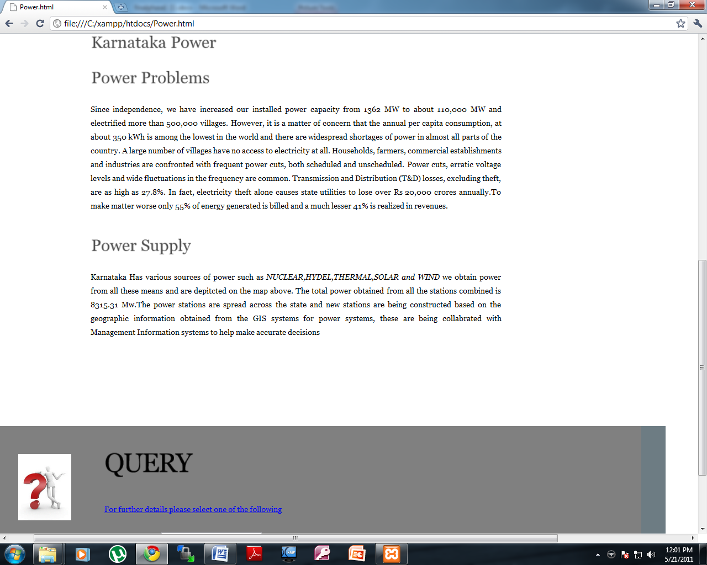

Figure 8.3 Power tab of web Page

**8.1.2 QUERY**

The web portal has a Query aspect to it using which users can query required information, in the case of POWER SYSTEMS a user can query based on NAME OF POWER STATION, TYPE OF POWER STATION or THE DISTRICT.

A user can enter any of this information and obtain information required by them.



Figure 8.4 District Query part of web portal

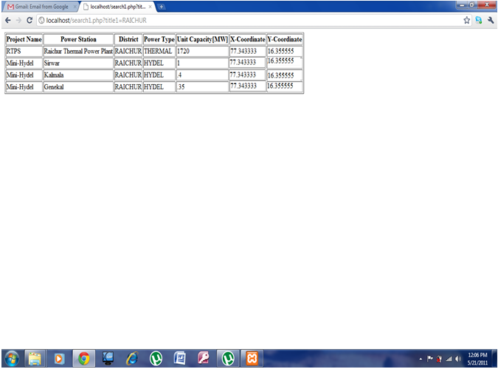

Figure 8.5 Result of the Query

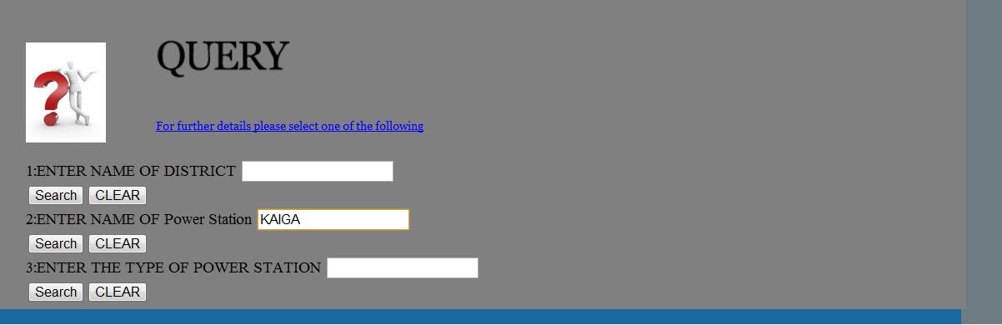

Figure 8.6 Power Station Query

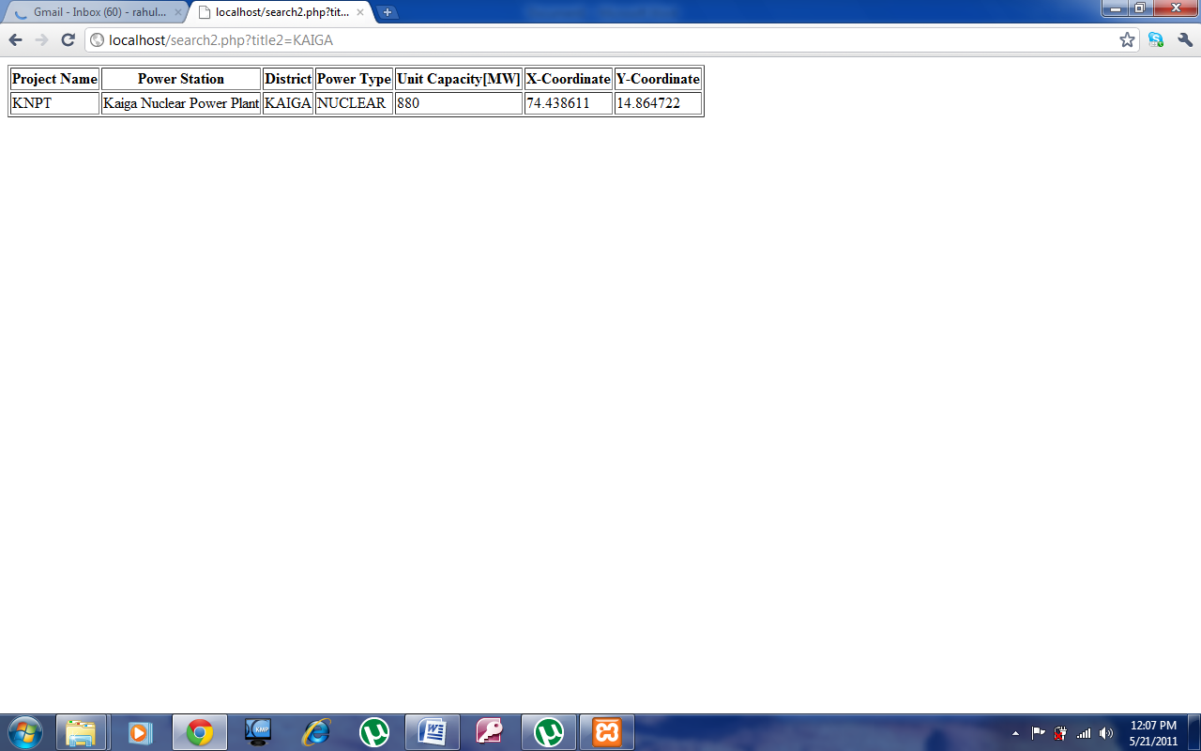

Figure 8.7 Result Of the Query

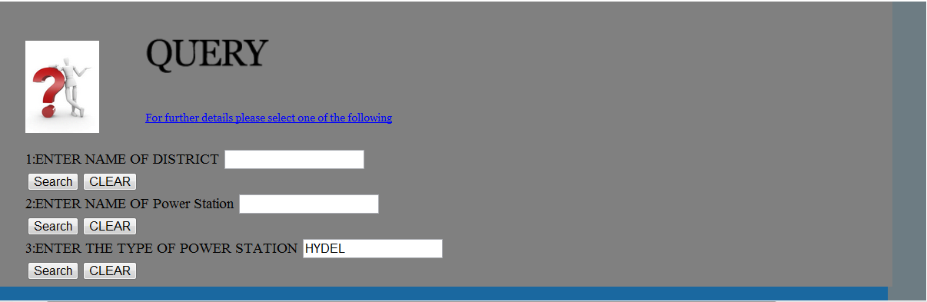

Figure 8.8 Type Of Power Station Query

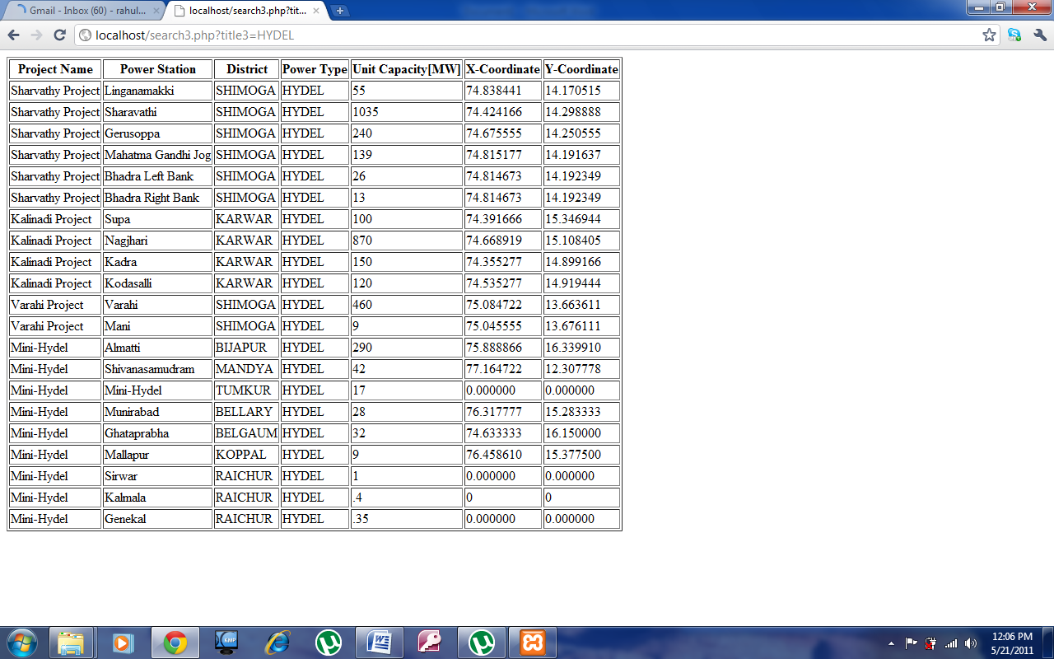

Figure 8.9 Result Of the Query

**8.1.3 DATABASE CREATION**

The database is created using Xampp and Myphp admin.

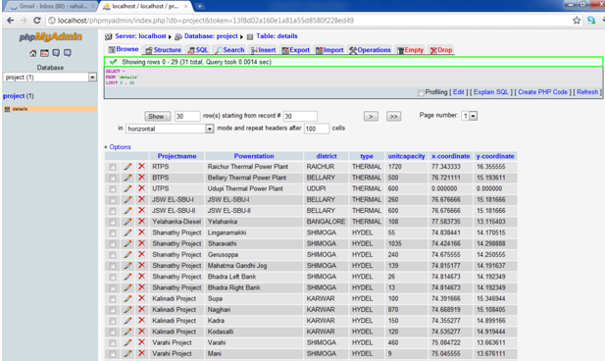

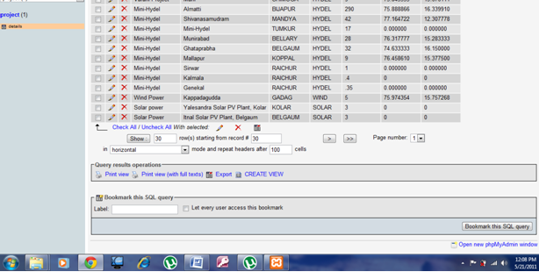

Figure 8.10 Database Created Using XAMPP

**CHAPTER 9**

**CONCLUSION & FUTURE SCOPE**

**CHAPTER 9**

**CONCLUSION & FUTURE SCOPE**

**9.1 CONCLUSION**

The above project concludes that the project can be implemented by the government or any private service providers, successfully for the Power system facilities in Karnataka state so that the Power Corporation of the state (KPTCL) can utilize the advanced technology of remote sensing and GIS. The technology can also be adopted throughout the Nation to improve the power distribution also can be expanded to other fields such as Medicine, Road network, Tourist Destination etc.. GIS used as a tool for the application of LBS (Location Based Services) can be integrated with latest mobile technologies in such a way that a person or the user can trigger the current location by sending a SMS to the concerned web server so that the servers can send the details of nearby Power station integrated with the maps so that the Engineers can have easy access to the required Power Plant. The system can be installed at the important tourist spots or places like Railway stations, Air ports; Bus stands etc., so that the commuters can utilize the facility. The existing system involves a lot of manual work and data is lost dude to carelessness and this GIS system integrates all the data onto a system using a Database and users can use MIS and Data mining technology to query information. But in this project, any common man can send the query depending on the requirement and the server will list the details accordingly using the web Portal developed. Overall the purpose of this project is to benefit the common man for POWER facilities and other services in the city and to improve the utilization of the system.

**9.2 FUTURE SCOPE**

The system developed can be further expanded, these are mentioned below

* Providing real time information about the traffic on a road
* Providing the Popular Tourist Destination
* Providing list of Hospitals in the surrounding area
* Providing Climate information on real time
* Providing a way for a consumer to lodge complaints
* Providing information regarding Bus routes
* Providing a mechanism to calculate power consumed and generated to find out power loss
* To identify areas of power shortage
* To identify New locations for Power Plants

**CHAPTER 10**

**REFERENCES**

**CHAPTER 10**

**REFERENCES**

1. <http://www.gisdevelopment.net/application/urban/products/urbanp0005pf.htm>
2. <http://www.planning.kar.nic.in/sites/planning.kar.nic.in/files/AnnualPlan2011-12/vol-I/10%20-%20Chapter10-F_199-218_.pdf>
3. <http://en.wikipedia.org/wiki/Wind_power_in_India#Karnataka_(1472.75_MW)>
4. <http://www.upcl.org/it-GISinPowerDistribution.pdf>
5. <http://toolserver.org/~geohack/geohack.php?pagename=List_of_power_stations_in_India&params=14_51_53_N_74_26_19_E_>
6. <http://www.d-maps.com/carte.php?num_car=8766&lang=en>
7. <http://en.wikipedia.org/wiki/List_of_reservoirs_and_dams_in_India#Karnataka>
8. <http://www.planning.kar.nic.in/sites/planning.kar.nic.in/files/AnnualPlan2011-12/vol-I/10%20-%20Chapter10-F_199-218_.pdf>
9. <http://eng.hi138.com/?i280554_Analysis_of_power_supply_enterprise_development_and_application_of_Geographic_Information_System>
10. <http://www.ikg.uni-hannover.de/agile/fileadmin/agile/paper/132.pdf>
11. <http://www.waset.org/journals/waset/v60/v60-155.pdf>
12. <http://en.wikipedia.org/wiki/Geographic_information_system>
13. <http://www.karnatakapower.com/projects.asp>
14. <https://www.powergridindia.com/PGCIL_NEW/home.aspx>
15. <http://powermin.nic.in/JSP_SERVLETS/internal.jsp>